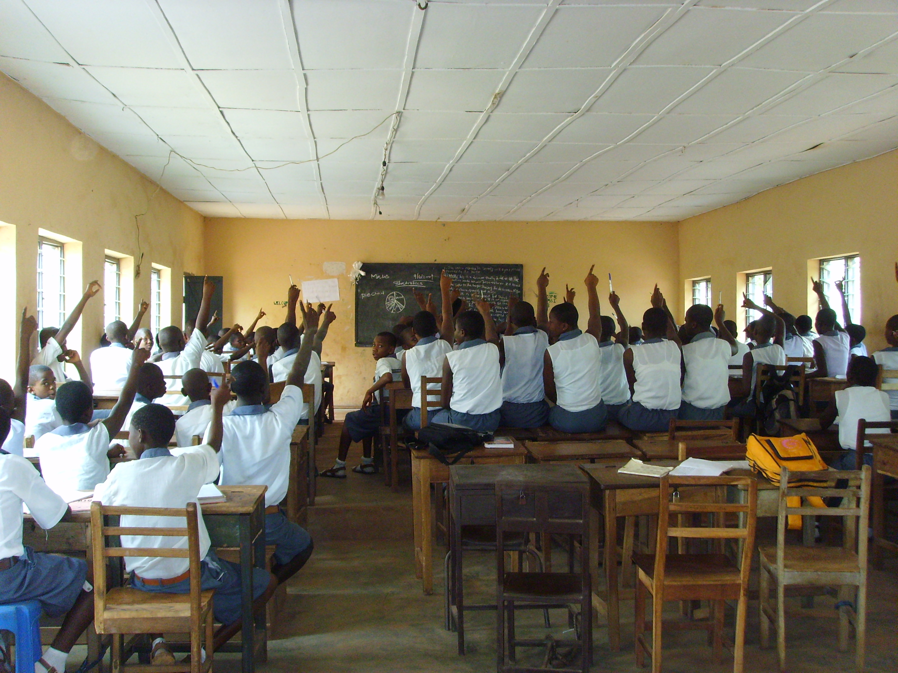

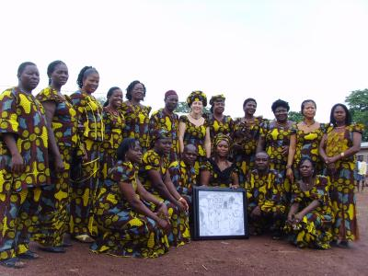
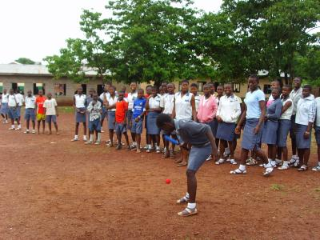

Nigerian traditional clothing
Nigerian Clothing is completely based on the Nigeria Culture. As Nigeria is a multi-ethnic, there are lot of ethnic groups and each of them have their traditional dress code. Clothing in Nigeria have a great variety. In the north, people prefer their outfit based on their work. In the south, people are pretty much fond of dressing up.
Important materials for Clothing of Nigeria are lace, jacquard, adire, ankara. Nigerians are also fond of tie and die materials. Nigerian Clothing for women includes buba, kaba, iro, gele and iborun or ipele. A buba is a loose blouse that goes down little below the waist. Kaba is basically a single piece dress, which can have different styles. Iro is the bottom part of clothing, which is a rectangular piece of cloth that is wrapped around the waist. Gele is a head gear. It is a rectangular piece of cloth that be tied in different ways to give different looks. Iborun or ipele is a scarf that is either tied around the neck or just can be put diagonally across the body.
Nigerian Clothing for men comprises of buba, fila, sokoto, abeti-aja and agbada. For men, buba is a loose shirt that goes down till halfway down the thighs. Fila is a cap. Sokoto is the the pant or trouser, which covers the lower part of the body. Abeti-aja is another type of cap, which have longer sides. Agbada is a festive clothing that is made by comprising buba and sokoto. Thus Nigerian clothing can be said to be quite creative and interesting

