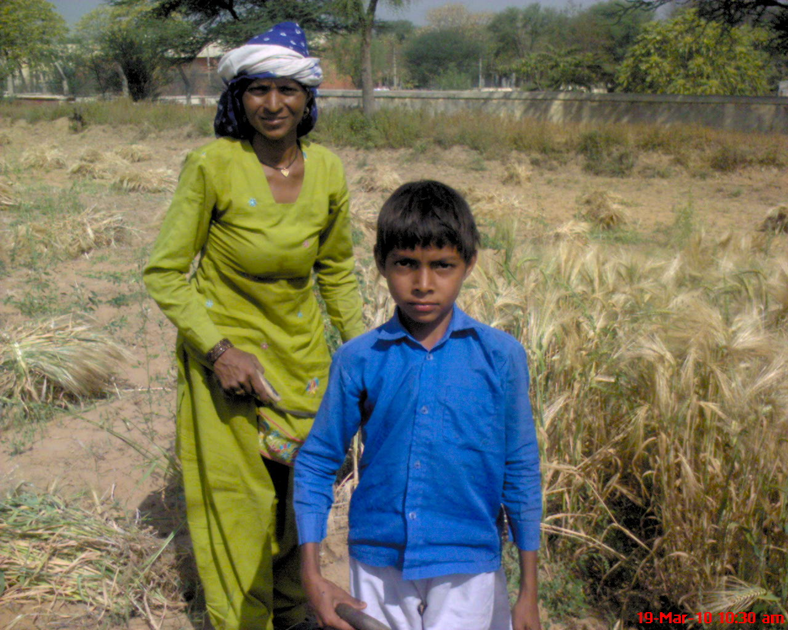

What he planned?
For anyone it may sound awkward if a boy simply puts up a question like this, but for me it was not at all odd. I went to a nearby field to take snap of people working in fields. There I saw a woman with her son harvesting their crops. My mother asked the woman where her husband was. To this question she replied that he was away to drink wine. The boy just of my age group was holding an axe in his hand and deftly cutting the stalks. I asked him how he celebrated Mother’s Day. He asked me what this day is. I was surprised for a moment and later realized that it was foolish of me to ask him about the day as he lives in a remote village of India and is not well aware about such things.
Nevertheless, the boy told me that for him every day of his life is a Mother’s Day as he looks after her and helps her in doing all household chores. The mother was also affectionate to her son and praised his sensitive nature and helping attitude.
I asked him what he would give his mother on that day. He told that he would touch her feet and seek her blessings and cook food for her. He told about his future plan of moving to a city and giving his mother all facilities. There were tears in his mother’s eyes. What else can a son do for his mother to repay his debt? He was so loving and simple-hearted. I had no words to say.

