A day in my life
It was the 28th-july.I came back home as usual at 12:30 but here comes the surprised when I opened my house door then I heard people singing everywhere "happy birthday to you.." my whole whole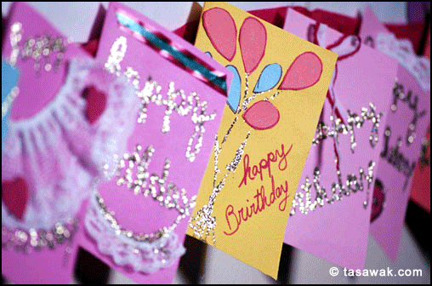 family surrounded me they were singing &clapping then they look me to the lioingroom where the prepared food& some gifts for me. I was very happy it was my thirteen birthday I had lovely moments with people that I love.

Written by: Afnan mady.
AL-zaiton prep girl school.

