STUDENT WORKSHEET

Planning a trip for your ePals using the Internet

Students –class-6th JNV Bhiwani India

What day do you want to travel?

Monday is the best day to start the travel as we can see a lot of things and there will be no crowd as other days.

What is your village famous for?

Our village is famous for temples and green farms. Here people are generally well-to-do compared to other villages of Haryana. Devsar Temple near our village is a famous religious place and people from far places visit here.

What clothing do you have to bring?

During summer you need to bring fewer clothes. Half-pants, t-shirts and cotton clothes will be required. You need not bring a lot of luggage. Vehicles are easily available here for excursions as native people travel a lot.

List 3 nice places in the area:

Devsar Dham

Loharu Fort

Star Building

List 3 different kinds of restaurants there:

Yellow Chilli

Bikanerwala Sweet Shop

Adarsh Misthan Bhandar

Choose one restaurant to eat and say why you chose this one?

Yellow Chilli Restaurant will be the best one as the dishes served here are of various origins. You can have Italian dishes as well as Chinese one. South Indian Dishes are delicious and light. Sitting arrangement is also good whereas in other restaurants it is crowded and sweets are found generally. Here you can have soups and fruits’ juices also. Tasty ice creams and desserts are inviting.

What is the history of the village?

District Bhiwani was created on 22 July, 1972. The district headquarter is situated in Bhiwani town. Bhiwani has 442 villages, with main towns being Charkhi Dadri, Loharu, Bawani Khera and Tosham. The total area of Bhiwani district is 5,099 sq kms. Bhiwani city finds mention in Ain-e-Akbari. It is claimed Bhiwani was founded by the Rajput name Neem after his wife named Bhani. The Bhani word later changed to Bhiyani and subsequently to Bhiwani. Bhiwani has been a prominent center of commerce since time of Mughals. Bhiwani is also known for its temples and is called as small Kashi of India because of numerous temples. Another important city of the district is Dadri which was founded by the son of Prithvi Raj Chauhan. It is also a hub of commercial activity.

What is the population?

Its population is 14,24,000.

What is the major source of employment in this village?

In villages people generally depend on farming and dairy but in main city many commercial activities are there. People from here have settled abroad as in Italy, America, U.K., and Canada. From our village itself 30 persons work in Italy and live with family there. Some people do services and other do businesses in other parts of country. In villages they have built magnificent houses where their servants live and often they visit village during summer vacations with their families.

What important events are there and in what period of the year?

People gather on occasion of main festivals as Holi, Diwali, Raksha –Bandhan and other National Festivals like Republic Day and Independence Day. Holi is celebrated in the month of March, Diwali in October or November. Raksha –Bandhan is celebrated in month of August generally. These Indian Festivals depend on Moon so the dates and months vary year to year. Independence Day is celebrated on 15th August and Republic Day on 26th January.

List 3 things you want to do while you are there:

We can see farms and interview the farmers.

We can visit a nearby herbal park in Kairu to see various kinds of herbs and roses that are used in making medicines and scents.

Nearby Bahal is famous for Educational Institutes of International fame so we can visit B.R.C.M. Engineering College and residential B.R.C.M. School.

Can you go camping near the village?

We can camp in B.R.C.M. Engineering College’s Campus or in Kairu. Even our humble village Devrala has no dearth of beautiful camping sites. Near our School we have a lot of space and in our campus itself which is spread over 35 acres we can camp.

Where?

It will be better to camp outside the village where farms are so spacious and natural sights are attractive to watch.

What do you like most about this village?

The green farms and simple affectionate people are the best things about our village. You need not fear anything. The people are helping and it is a peaceful area.

Which website shows the most beautiful picture of the area?

Google’s Wikimapia shows the accurate and beautiful picture of our area.

Add here the picture:

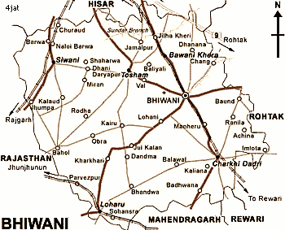

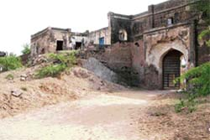

Loharu Fort

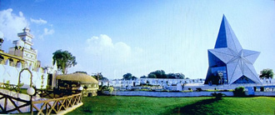

Star Building

Where can you go shopping?

We can go for shopping in village Devrala which is 2 kms away from our School but if we have to buy branded things we can go to main city Bhiwani where Koutons and other branded shirts, jeans are easily available. All kinds of things are available there.

List any cultural things to do (museums, art galleries...)

Here in Bhiwani we can see a mini zoo. Colleges of Bhiwani, nearby Kairu and Bahal have wonderful libraries worth-seeing. But nothing in particular is popular in our city.

What do you think are the top 3 tourist destinations in the village?

Devsar Dham

Loharu Fort

Star Building

