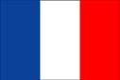
France

France is an independent nation in Europe. It is the largest country in Europe and has the largest capital, Paris. France had its role in major European and world events.Wikipedia.org/wiki/history of France, Wikipedia.org/wiki/France national football – team, nationsencyclopedia.com/economies/Europe/France.html

FIFA world cup
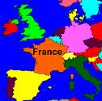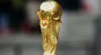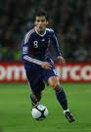

As all other countries sports is a major elements in France. The sports in France include football, rugby and handball. In 1938 and 1998 France hosted the fifa world cup championship. But in 1938 it didn’t win, it won the cup at 1998. Stade de France is considered to be the largest stadium in France. Both the Football and the rugby national teams are called “les Bleus” or the “Blue ones “, because their team shirt’s is colored blue.

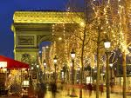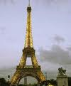

In over seas departments, which are under the control of the French Government, like Gaudelope and the Martinique Islands, teams in these departments, are not allowed to enter the fifa world cup. But player of these departments can join any football team who plays in fifa, like France, Italy, Spain etc……Many over seas players play within “les Bleus “ team like Thierry Henry, William Gallas, Bernard Lama and other more …

In 2010 the fifa world cup is hosted in Africa, and France is going to play with “Les Bleus “team. Is France going to win the cup this year too to be holding the cup twice or not?
By: Alya Jradi/ Gr. 6 A
GREECE
History:
Greece had a war with empire Ottoman and Egyptian khedivate and vilayet Tunisia. Every one was scared of Ottoman Empire since it defeated Bezant many revolts tried to finish Ottoman rule but they could not. Meanwhile, Greece had a war with Turkey and they defeated it and started with the Ottoman Empire to finish it.
King of Egypt sent his son to rule Greece and finish its revolts but Greece was ready for them so they destroyed the son and his army. Three powerful nations helped Greece in having its independence and they were America, Russia and France. But France helped the most by killing Ottoman and Egyptian khedivate army. Finally Greece had its independence in 1832.

Location:
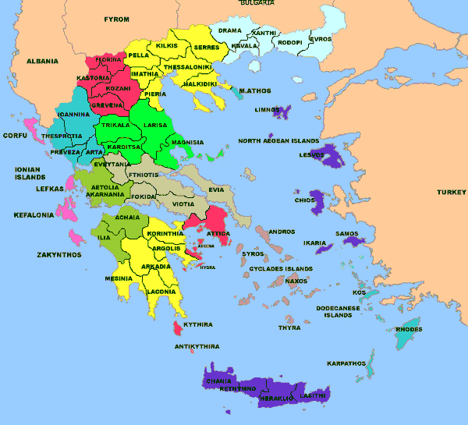

As you see Greece is in Europe and it is next to Asia and it has a lot of islands and by it island we can go to Turkey and it has 56 cities in it.

Greece National Team:
Greece had only two chances to win a cup, but sadly it didn’t win anything but in the second chance they were the European champions. Greece was competing against France in a Game for the tournament and Portugal for the final. Later Greece was more popular. It began taking higher ranks and it had more fans than before whether there was a stadium or not. In a regular match between Australia and Greece, fans of Greece were 95,103.
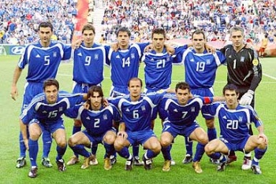

Done by: Hadi Ahmad

The territory of present day Cameroon was first settled during the Neolithic. Baka was the longest inhabits group. The Sao culture arose around Lake Chad c. AD 500 and gave way to Kanem and its successor state, the Bornu empire. Kingdoms, fondoms,and chiefdoms arose in the west.

Ethnic groups has its own special culture forms. Typical celebration include birth, deaths, plantings, and harvest. Seven national holidays are observed throughout the year, and moveable holidays include the Christians holy days of Good Friday v, Easter Sunday, Easter Monday, and Ascension; and the Muslim holy days of ‘Id al-Fiter, ‘Id al-Adha, and Eid Milad Nabi

Location:

The Republic of Cameroon is a unitary republic of center and western Africa. It is bordered by Nigeria to the west; Chad to the northeast; the Center Africa Republic to the east; and Equatorial Guinea, Gabon, and the Republic of the Congo to the south.

Cameroon National Football Team:

The Cameroon national football team, nicknamed Les Lions Indomptables. Cameroon has qualified for th FIFA World Cup six times-in 1982, 1990, 1994, 1998, 2002 and 2010 nore than any other African nation.

By: Aya Mazbouh/ Gr. 6 A

SWITZERLAND

→ HISTORY

→ LOCATION

→ MONDIAL

HISTORY:
THE SWISS CINFEDE-RATION HAS BEEN A FEDERAL STATE OF RELATIVELY AUTONOMOUS CANTONS, SINCE 1848. SOME OF THE PEOPLE THAT HAVW A HISTIRYT OF CONFEDERACYTHAT GOES BACK FOR MORE THAN 700 YEARS, ARGUABLY PUTTINGTHEM AMONG THE WORLD’S OLDEST SURVIVING REPUBLICS.

LOCATION:
SWITZERLAND IS A LANDLOCKED COUNTRY WHOSE TERRITORY IS GEOGRAPHICALLY DEVIDED BETWEEN THE CENTRAL PLATEAU THAT 7.8 MILLION PEOPLE CONCENTRATE THERE, AND THE ALPS AND THE JURA ALSO.

MONDIAL:
IN 1954 FIFA WORLD CUP THE FIFTH STAGING OF THE WORLD CUP, WAS HELD IN SWITZERLAND FROM 16 JUNE TO 4 JULY. IT WAS APPROIATE FOR FOOTBALL’S PREMIER COMPETITION TO BE PLAYED IN THE HOME OF its GOVERNING BODY, WHEN THE YEAR SAW THE 50th ANNIVERSARY OF FIFA. IN JULY 1946, SWITZERLAND WAS CHOSEN AS HOSTS. WEST GERMANY WHO DEFEATED THUNGARY 3-2 IN THE FINAL WON THE TOURNAMENT GIVING THEM THEIR FIRST TITLE.

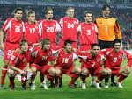

By: Lama Khawaja/ Gr. 6 B

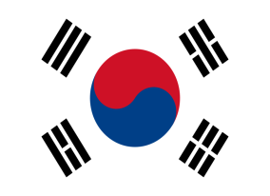
South Korea

Location:
South Korea occupies the southern half of the Korean Peninsula in eastern Asia. It is bordered by North Korea to the north, the Sea of Japan / East Sea to the south and to the east, and the Yellow Sea to the west.

National Team
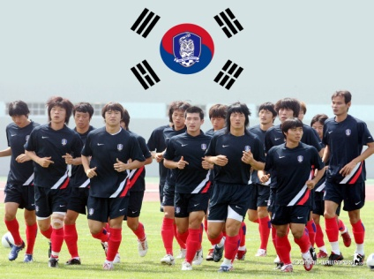
The Korea Republic national football team represents the Republic of Korea in international football competitions. The team, also known as South Korea, is recognized as Korea Republic by FIFA.
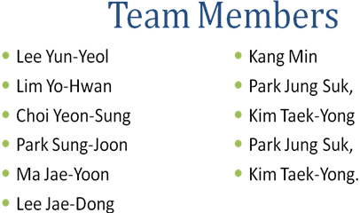

By: Mahdi Bahsoun/ Gr 6 B
Paraguay

The Paraguay national football team is a team that reached to the second , round of the world cup in 1986 & 1998 &2002.And never took the word cup but they won once a silver medal in the football tournament at the Athens 2004 Olympic games. After that, the trainer was named Williams Paats. The members were; M. Barrio Z.gadea….. Paraguay once participated in the world cup in 2003.
Paraguay was a poor country till the president Linton came and improved it. Paraguay is a country that is famous in football and baseball.

First, it lost when it faced U.S.A. 0/1, and then won 1/0 by playing against Vargos .Paraguay also won world Copa America, it played against Brazil.

New Zealand

Location:
New Zealand is in the Southern Hemisphere, lying between 34 and 46 degrees of latitude south in the Pacific Ocean. This puts us at about the same distance from the equator as Spain or California. Our nearest large neighbour is Australia which is 1500Km (930 miles) to the west.
2200Km / 1350miles to the south, across the Southern Ocean, lies the frozen desert continent of Antarctica.
New Zealand national football team:
The New Zealand national football team, nicknamed the All Whites, is the national association football team of New Zealand and is governed by New Zealand Football. The team plays in an all-white strip, hence its nickname.
The All Whites played in the 1982 FIFA World Cup and on 14 November 2009 qualified for the 2010 FIFA World Cup. Because of the lack of a high-quality domestic league, most top New Zealand footballers play in the leagues of Europe, in the United States, or in the Australian A-League.
New Zealand formerly battled Australia for top honours in the Oceania Football Confederation (OFC). This is no longer the case as Australia now plays in the Asian Football Confederation, leaving New Zealand as the only seeded team in OFC. New Zealand has won the OFC Nations Cup four times - in 1973, 1998, 2002 and 2008.

By: Batoul Ezzelddine/ Gr. 6 B

