EXAMPLE OF AN INGREDIENTS LIST

INGREDIENTS AVAILABLE TO BUY!

 Tomatoes – €0.20 each

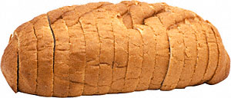

Bread - €1.20 per loaf

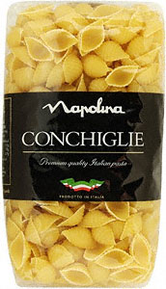

Pasta - €1.30 per packet

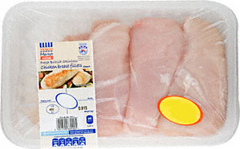

Chicken fillets - €7.20

*--------------------------------------------------------------------------------------------------------------------------*

*This list was made by finding the items on* [*www.mysupermarket.com*](http://www.mysupermarket.com) *and then using a currency converter to convert the price to euros -* [*http://www.xe.com/ucc/?utm_source=internal&utm_medium=TL&utm_content=NOGEO&utm_campaign=UCCin404TL*](http://www.xe.com/ucc/?utm_source=internal&utm_medium=TL&utm_content=NOGEO&utm_campaign=UCCin404TL)

This kind of pricing would be fine to use with younger children or to use with students doing the activity themselves on the computer because it’s the easiest way to find items and convert their cost. However for more accurate costs, prepare an ingredients list by searching the living costs in your chosen country and in its currency.