Welcome to eLanguages

Login
To login, go to the eLanguages home page, and enter your login details in the top left. www.eLanguages.org

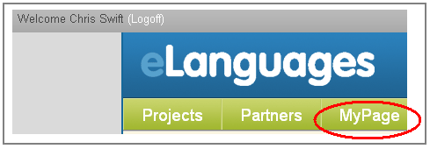
MyPage
Once you’ve done this, you will be able to access the section called “MyPage”. This is the administrative area where you can change personal details, password etc. You can also access your “hello page” which is your own personal or school profile outlining what you are looking for, or hoping to achieve. Here is an example: http://www.elanguages.org/view_profile.php?accountid=6345;resourceid=55744;route=resourceid
Your first task should be to add some information about yourself and school to your “hello page”.

Search for a Project
Use the “Projects” and “Partners” buttons to search by age group, country, or language.
Or simply search a certain word or phrase (eg “environment”) by using the search box in the top right of the page.

Start your own Project
You can also start your own project (this is in MyPage>What’s Next?>start a new project). You just need to complete the necessary fields when you do this, and then you can start to build your own page with text, documents, pictures etc.

Community
eLanguages is an online community for teachers, so feel free to get in touch with any of the teachers on the website. You are free to join anyone else’s project by sending them a message. You can do this by the “send me a message” function available on all “hello” pages.
If any of your colleagues are interested, they can register also. They just need to e-mail the team at:
eLanguages@britishcouncil.org
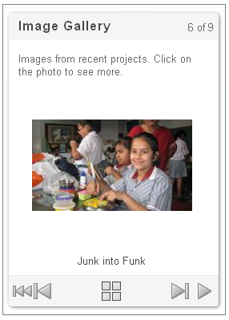
Help guide
Learn how to use the website and make your own project http://www.elanguages.org/7809

Change your password
To change your password click here

Recent Activity
Have a look at the newest members and projects: http://www.elanguages.org/62348

Newsletter
To read our latest newsletter, please click here: http://www.elanguages.org/85929

