I love greenery very much. Green Environment gives us freshness. Green colour gives life. It is the symbol of growth. We should all join hands to promote the growth of more and more trees. This is the view outside my house. I can see many trees- big and small from the window of my bedroom.
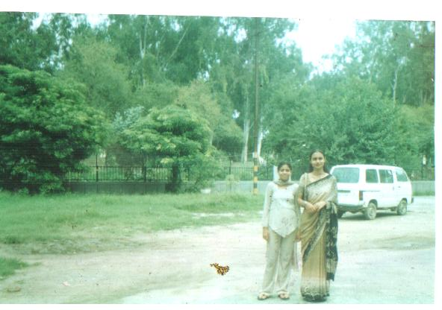
Raghav Sood V A

