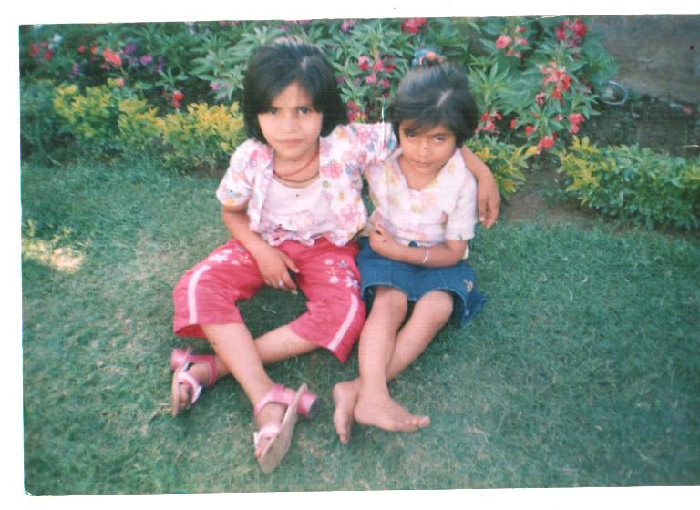
This is the view of a garden. I can see it everyday from my balcony. I and my sister go to the garden every evening. We enjoy walking on the green grass and we swing on the swings. We play games and enjoy a lot. On Sunday, my parents go with us to the garden and we enjoy together. My dad has a mobile with camera and he takes our photographs. We feel fresh after coming back from the garden.
Yashu Raghav V A

