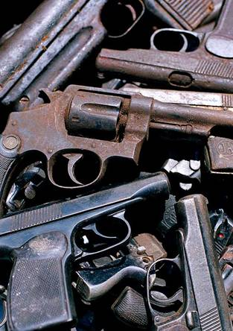
Armed Conflict Quiz

1. Out of approximately 193 countries in the world, how many countries experienced armed conflict in 2002?
- 21
- 42
- 67
2. What proportion of the world's countries spent more on the military than on health-care (in 2002)?
- one-fifth (1 in 5)
- one-third (1 in 3)
- half (1 in 2)
3. Between 1997 and 2001 what percentage of developing countries experienced a civil war?
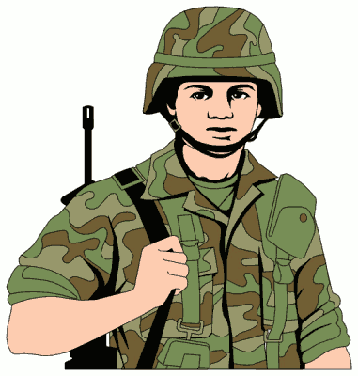
- 26%
- 41%
- 56%
4. In World War One, what percentage of casualties were civilians?
- 14%
- 67%
- 90%
5. What percentage of casualties were civilians in World War Two?
- 14%
- 67%
- 90%
6. What proportion of those killed in conflict since 1989 have been non-combatants (civilians)?
- 14%
- 67%
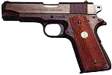
- 90%
7. How many small arm weapons are there in the world?
- 639 million
- 749 million
- 829 million
8. What percentage of small arms are in civilian hands (not soldiers)?
- 60%
- 70%
- 80%
9. How many children are estimated to be involved in conflicts worldwide (2002)?
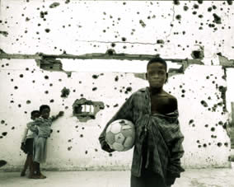
- 3,000
- 30,000
- 300,000
10. Article 38 of the Convention on the Rights of the Child states that you have a right to protection in times of war and should not have to be in an army or take part in a battle under what age?
- 12
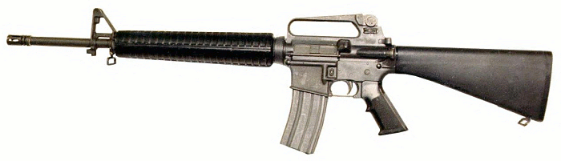
- 15
- 21


Armed Conflict Quiz
- 42
In the last 20 years there have been more than 120 wars worldwide.
- One-third
An average of 22 billion US dollars a year is spent on arms by countries in Africa, Asia, the Middle East and Latin America. From 1998 to 2001 the USA, the UK and France earned more income from arms sales to developing countries than they gave in aid.
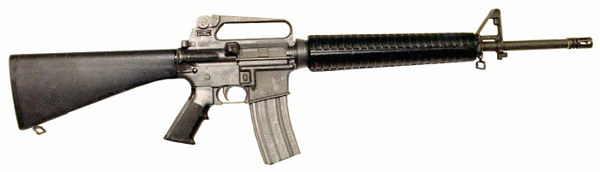
- 56%
Wars today are concentrated in the poorest countries and these countries can very easily get caught up in a cycle of poverty and conflict.
- 14%
- 67%
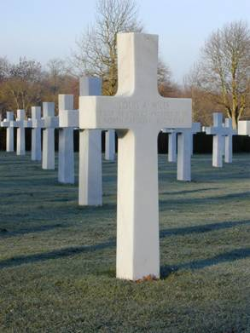
- 90%
This is the figure since the end in 1989 of the 'Cold War' which marked a change in the types of conflicts and how they were paid for.
- 639 million
That is equal to one for every ten people. 8 million more small arms are produced every year.
- 60%
Small arms kill more people than Weapons of Mass Destruction.
- 300,000
It is estimated that roughly 300,000 children under the age of 18 are still participating in armed conflicts around the world.
- 15
Part three of Article 38 of the UN Convention on the Rights of the Child states: ‘Parties shall refrain from recruiting any person who has not attained the age of 15 years into their armed forces. In recruiting among those persons who have attained the age of 15 years but who have not attained the age of18, parties shall endeavour to give priority to those who are oldest.’
Armed Conflict Key Facts
- Since 1990 90% of the people killed in conflicts have been civilians (not soldiers)
- There are enough small arms to share them out one for every ten people in the world
- Each year enough units of ammunition are produced to kill everyone on the planet twice
- A third of the countries in the world spend more money on military than on health care
- China, France, the Russian Federation, the UK and the USA are the top five arms exporters in the world
- From 1998 to 2001 the USA, the UK and France earned more income from selling weapons to developing countries than they gave in aid.
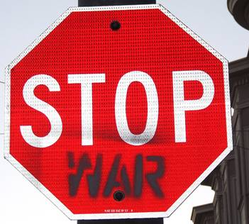
- It is estimated that roughly 300,000 children under the age of 18 are fighting in armed conflicts around the world
Armed Conflict Key Questions
- Why do conflicts take place?
- How can conflicts be resolved?
- What if there was peace in the world, how would life on our planet change?
- Could you be at peace with everyone you meet for one day, one week, one year?

