‘The Cambridge School’

vs

‘Amity International School’.



The Logos:

The Building:
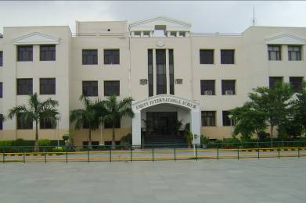

The Cambridge School Amity International School

Scholastics;
The time spent on lessons is the same in both cases. However, the number of subjects taught is not the same as the Indian schools have to follow the three language rule in the middle school till Class VIII. Other than that, the subjects remain the same: Science, Mathematics and Social Sciences.

Non-scholastics:
The Cambridge School has a host of clubs which are operational during the breakfast and lunchtime breaks, as well as after school hours. All these are run with the active participation of the parent and the neighbourhood community. The clubs on offer are as follows - Girls Clubs, Art/Music Club, Mentoring Drop in Club, Drop-in, Fitness Club, Rock Group, Drumming, Media Club After School Clubs run four days of the week, Monday to Thursday. They include across the year - Street Dance, Healthy Eating and Cooking, Arts and Crafts, Film Club, Computers and Media Club, Homework Club, Football, Basketball. The school also works in partnership with HAFAD, the local Men cap provider. They offer after school provision, youth clubs and Saturday Club to students from Cambridge School. They also run Holiday Clubs for 2 weeks in the summer, and 1 week at Easter. These are very popular and are generally reserved for students who are particularly suited for this provision. Availability depends on staffing levels.
At Amity, we have club meetings on a weekly basis rather than on a daily basis. The students have to choose between performing arts and visual arts, sports being compulsory. Under these major heads, there are a variety of choices which the student can opt for depending upon his/her aptitude and interest. We have Indian classical music, Indian classical dance, contemporary dance, instrumental music, public speaking, fine arts, pottery, craftwork, etc. In sports the student can choose from football, volleyball, basketball, table tennis, archery, tae-kwan-do, chess and athletics. The school conducts a summer camp during the summer vacation, a fun-filled time, which is very popular.

