THE IDEAL SCHOOL

Education in Bulgaria is compulsory for all children aged between 7 and 16.When children are the age of 7 they start primary school. Secondary school is for students from the age of 11 to the age of 18.
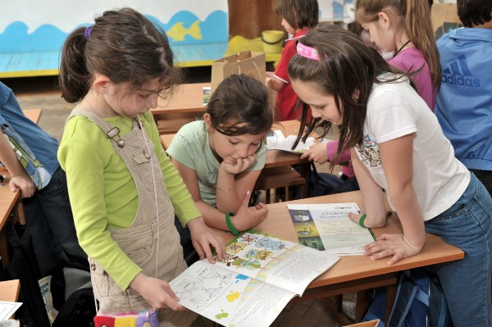
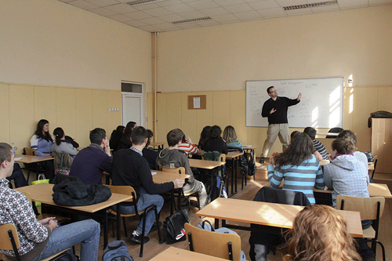
Compulsory subjects are English, Mathematics, Music, Bulgarian language, Art. They can choose which subjects to study.At the end of the year 12 students have to do two exams.These are necessary for university entrance.
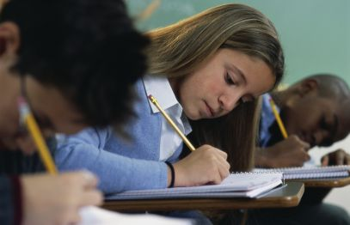
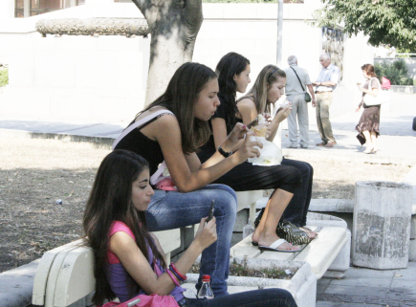
Students start school at half past eight and finish at half past two.Every day they have six lessons and they are 45 minutes.The long break is twenty minutes and students usually have breakfast.

At school students play basketball, football and volleyball. There are Easter, Christmas and summer holidays. Easter and Christmas holidays are ten days long.Summer holiday is about three months. The school finishes on 15 June.

