دولة الإمـارات العربية المتحدة المــــادة : اللغة الإنجليزية

وزارة التربيـــة والتعــليم  زمن الإجـابة : ساعة ونصف عدد الصفحات : (6 )

( امتحان تجريبي – 2010/2011 – للصف الحادي عشر 

على الطالب التأكد من عدد صفحات الأسئلة

(الإجابة على الورقة نفسها)

100
- Reading
Directions (30 items. Each worth 2 points)
Part A. Reading 1
Read the selection below. Then answer the questions by circling a, b, c or d.
10
ARE YOU A SHOPAHOLIC?
Shopping can be a pleasurable pastime, but for some people it can turn into an addiction. The good news is there are some simple steps you can take to overcome a compulsive shopping addiction.
  Step 1  - Stop being lured in by good deals  - Make it a point to stop reading sales ads and brochures | Step 2  - Shop only from a list  - Each time you buy only what's on your list, reward yourself
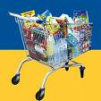  Step 3  - Keep accurate records  of your spending  - Set a goal of only  spending a certain amount on a monthly basis  - If you reach your goal, give yourself a small reward | 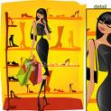  Step 4  - Take up a new hobby  - You may discover that  there are more enjoyable  ways to spend the day  than spending money  at the mall
- What is this brochure mainly about?
- Spending money c. Organizing free time
- Rewarding oneself d. Controlling shopping addiction
2. According to the author, you can save money by
a. visiting malls. c. shopping from a list
b. writing lists. d. reading sales advertisements.

3. Based on the text, you can avoid being a shopaholic by
a. practising new hobbies. c. writing brochures.
b. seeking out good deals. d. rewarding others.
4. According to the text, you can reach your goal by spending
a. time in malls c. time in reading brochures
b. money on good deals d. a certain amount of money every month

5. Which of the following statements BEST describes the author's opinion on
over-shopping?
a. It is enjoyable. c. It is a bad way of wasting money.

28
b. It is a good hobby. d. It is a good way of achieving goals.

Part B. Reading 2
Read the selection below. Then answer the questions by circling a, b, c or d.
Paragraph 1  Paragraph 2  Paragraph 3  Paragraph 4  Paragraph  5 | Nowadays, more and more families are turning to maid services to help free up valuable time and keep their home looking neat.  The common reasons why some families have maids are basically to care for babies and young children and the sick and elderly. Most people have to work during the day and come back home tired. If they have a sick or old person at home, how are they going to care for them and attend to their needs? Engaging a maid at home is the other alternative to sending them to a nursing home, which I think is unpleasant.  Having a maid is very much a necessity for most families these days. A maid makes our lives much easier most of the time. For a mother and wife, a maid aids her with her daily chores and gives her more quality time to be spent with her children and husband.  As a result, we will automatically become dependent on the maids because most of the house chores are done by them. Maids tend to fill in the void of parents who want their houses to be clean and their children to be taken care of. Even the kids become spoiled, dependent and lazy.  What is more, some of the maids are dishonest and they are often unfriendly once no parents are there. Many nanny cameras caught on film how they hit and abuse the kids. And recorded them stealing or killing!
6. What is the text MAINLY about?
- maids in the UAE c. helpful and honest maids
- the necessity of maids d. the advantages and disadvantages of maids

7. The word “valuable” line 2 is a / an
a. verb c. adverb
b. noun d. adjective

8. The word “alternative” line 6 means
- choice c. effect
- reason d. offer

- Based on the text, which of the following statements is NOT TRUE?
- People are happy to send the elderly to a nursing home.
- People have maids to take care of their children.
- People depend on maids to do daily chores.
- Children are sometimes treated badly by maids.
- In which paragraph would the following sentence fit?
“Maids will also reduce the household work.”
- [1] c. [3]
- [2] d. [4]
- The word “aids” line 9 means
- depends c. gives
- argues d. helps
- The word “ void” line 12 means
- place c. time
- side d. need
- According to the text, the children of families who mainly depend on maids may become
- strong and independent c. helpful and caring
- spoiled and dependent d. dishonest and unfriendly
14. The word “dishonest” line 15 is a / an
a. verb c. adverb
b. noun d. adjective

Dishonest maids could…..
15 ………………………. kids | 17. ………………………. kids
16. ………………………. kids | 18 ……………………….. things  22

Part C. Reading 3
Read the selection below. Then answer the questions.

Paragraph 1  Paragraph 2  Paragraph 3  Paragraph 4  Paragraph 5 | I have seven older sisters. They can be loud and bossy, so when we have family gatherings, I sometimes escape outside with my brothers-in-law.  However, when I think back on my childhood, I have only pleasant memories. Being the only male child and the youngest in a family full of women had some important positive  effects on my life.  First, being the only son made me stand out in the family, especially to my father.  My father truly enjoyed being around his “girls” – my mother and sisters – but I realize now that because he had only one son, he paid more attention to me and he often did special things with me.  As I was growing up, I learned to value the company of my sisters. They were my  models since they were older than I. My sisters welcomed me as a playmate, even though I was younger. All my sisters made me feel so loved that I truly enjoyed and sought their company. I really grew to enjoy living in a house full of women.  Finally, having so many female siblings affected my relationships with women in general. Because I was close to my sisters, I had the experience of understanding females and  knowing how to communicate with them. From my sisters, I learned to respect and admire  women’s intelligence and understand the difficulties of their roles in society. As a result, I think my sisters’ influence also helped me become a happily married man today.

19. The text is MAINLY about______.
- The writer’s wife c. The writer’s daughters
- The writer’s early life d. The writer’s brothers-in-law
20. The word “escape” in paragraph 1 means
a. get in c. get away
b. get lost d. get informed
21. The word “effects” in paragraph 2 is a / an
- verb c. adverb
- noun d. adjective
22. The word “especially” in paragraph 3 is a/an
- verb c. adverb
- noun d. adjective
23. Based on the text, which of the following phrases BEST describes the relationship
between the writer and his father ?
- loving and caring c. boring and tough
- serious and hard d. unfriendly and unpleasant
24. The word “value “in paragraph 4 means
- appreciate c. welcome
- recognize d. realize
25. In which paragraph would the following sentence fit? “I really enjoyed playing with my sisters."
- [ 1 ] c. [ 3 ]
- [ 2 ] d. [ 4 ]
26. The word “siblings” in paragraph 5 means
- playmates c. friends
- children d. sisters

How had the writer benefited from the fact of being raised with girls?
27. _______________________________ | 29. _______________________________
28. _______________________________ | 30. _______________________________

II. Writing

15
Part D Writing Sentences
Directions (5 sentences, each sentence worth 3 points - total of 15 points)
Look at the two pictures below. They show an event. Write 5 sentences (2 simple and 3 compound sentences) describing the event shown in the two pictures.
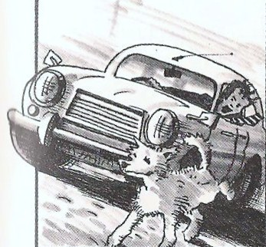
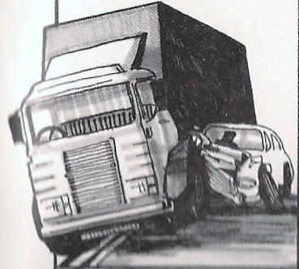
.

- ________________________________________________________________________

________________________________________________________________________

- ________________________________________________________________________

________________________________________________________________________

- ________________________________________________________________________

________________________________________________________________________

- ________________________________________________________________________

________________________________________________________________________

- ________________________________________________________________________

________________________________________________________________________

Part E Writing Multiple Paragraphs/Story (worth 25 points)

25
Directions
"Imagine yourself a real life hero. Write a story that happened to you."
Make sure you include:
- Who was involved?
- Where/ When did the incident happen?
- What happened?
- How did everything turn out?
- How did you feel?
الموضوع : " تخيل نفسك بطلا" حقيقيا". أكتب قصة حدثت لك
الأشخاص الذين شملتهم القصة
المكان و الزمان
ما الذي حدث؟
كيف انتهت الأحداث؟
ما هو شعورك بعد ذلك؟
Your essay should be between 150 – 200 words.
Pay attention to grammar, punctuation, and spelling.

__________________________________________________________________________________
__________________________________________________________________________________
__________________________________________________________________________________
__________________________________________________________________________________
__________________________________________________________________________________
__________________________________________________________________________________
__________________________________________________________________________________
__________________________________________________________________________________
__________________________________________________________________________________
__________________________________________________________________________________
__________________________________________________________________________________
__________________________________________________________________________________
__________________________________________________________________________________
_________________________________________________________________________________
_________________________________________________________________________________
__________________________________________________________________________________
__________________________________________________________________________________
__________________________________________________________________________________
Good Luck ☺

