دولة الإمـارات العربية المتحدة المــــادة : اللغة الإنجليزية
وزارة التربيـــة والتعــليم زمن الإجـابة : ساعة ونصف عدد الصفحات : (8 )

( امتحان تجريبي – 2010/2011 – للصف العاشر 
على الطالب التأكد من عدد صفحات الأسئلة
(الإجابة على الورقة نفسها)

100

- Reading

Directions (30 items. Each worth 2 points)
Part A. Reading 1
Read the selection below. Then answer the questions by circling a, b, c or d.

DO YOU KNOW?
What do you know about these countries?

Continent | Country | Important Facts
Europe | Germany | -It’s located in the heart of Europe.  -It’s famous for its forests, especially the Black Forest with its pine and fir trees.  -River Dani, the longest in Europe, passes through it.
Asia | Vietnam | -The South China sea lies to its east and west.  -It has vast areas of forests, wetlands and long coastline..  -Many rare and unusual animals live there.  -Two large rivers pass through it.
Central America | Costa Rica | -It’s located on the Caribbean Sea and the Pacific Ocean..  -It has 2 mountain ranges.  -One fifth of it is covered with forests.  -It’s home to 2,000 species of trees, flowers and plants.
Africa | Sudan | -The largest country in Africa.  -Lies on the Red Sea.  -The terrain is generally flat.  -The River Nile flows through it.  -There are swamps and rainforests in the west and big areas with wildlife.

Questions:

10

- You would probably find this information in a
- Cooking book b. Geology book
c. National Geographic Magazine d. Science magazine

- All the four countries
- lie in the heart if their continents b. have forests
c. lie on oceans d. have rare and unique animals

- The Black Forest is in
- Africa b. Asia
c. Central America d. Europe

- ___________ is the largest country in its continent.
- Costa Rica b. Germany
c. Sudan d. Vietnam

- If you want to go mountain climbing, you should go to
- Costa Rica b. Germany

24
c. Sudan d. Vietnam
Part B. Reading 2
Read the selection below. Then answer the questions.

Should public school children wear uniform? Honestly, I never understand the argument against wearing uniform. I wore a uniform through 12 years of my schooling. Looking back, I can see a huge number of advantages for parents, teachers and students. Here are just a few.
TIME SAVING: I didn’t have to think about what I was going to wear to school. It made the morning less hectic. It eliminates fight between parents and children over clothing choices.
MONEY SAVING: Having a uniform allows children to keep their best clothes for going out, and it allows parents to save money for more important things for their children.
EQUALITY: Uniform makes all children look alike and takes away all chances of judging others for their appearance.

But, many school children nowadays are against wearing school uniform. They say each student needs to show his uniqueness. It motivates them to attend school as they have new clothes to show, something not worn by others. That’s why, schools need to consider their students and negative and positive outcomes of having a uniform.

Questions:
Circle the most suitable answer a, b, c or d
- The writer, in paragraph 1, says
- People should argue about wearing uniforms
- She enjoyed wearing uniform at school
- Students shouldn’t wear uniform for 12 years
- Teachers should encourage students to wear uniforms

- The word ‘advantages’ in line 3 means
- Bad points b. Good points
c. Ideas d. Thoughts

- The word ‘eliminate’ in line 5 comes her as a/an
- Adjective b. Adverb
c. Noun d. Verb

- The writer believes, in paragraph 2, that wearing uniform
- Makes parents and children fight more
- Makes parents and children fight less
- Wastes children’s time
- Wastes parent’s time

- The word ‘equality’ in line 8 means being
- Different b. Less
c. More d. The same

- The writer, in paragraph 3, thinks by students wearing uniforms, parents
- Don’t spend too much on children’s clothing
- Save money for their children’s food
- Should encourage their children to wear uniforms
- Spend more time with their children

- The word ‘uniqueness’ in line 11 means being
- Alone b. Like others
c. The only one d. Tired
- The word ‘consider’ in line 12 means
- Decide b. Revise
c. Talk about d. Think of

- Complete the following sentences according to the text

- The writer didn’t need to _______________________________in the morning.
- Parents can save money if _________________________________________

- When all students wear uniforms, they don’t _________________________
- Students these days like going to school because ______________________
______________________________________________

26

Part C. Reading 3
Read the selection below. Then answer the questions by circling a, b, c or d:

Have you ever thought about why you like to eat chocolate so much? Most of us would answer “because it tastes so good”, but there is much more than that.

Studies show that chocolate stimulates your taste buds in a way that makes you want to come back for more. It also gives you a good feeling of well being as it stimulates the brainwaves and lowers the stress level. The lower your stress level, the more relaxed and happy you feel. This could be the reason why lots of people stuff themselves with chocolate when they are upset or angry. It also raises antioxidant level in your blood, and this helps in fighting many diseases.

One thing to remember is that it can have some negative effects on your body. That is when one consumes it too often. It has a very high level of sugar which can result in extra calories and fat which can lead to overweight.

Questions:
Circle the most suitable answer a, b, c or d:

- According to the first paragraph, most people eat chocolate because they
- Feel happy b. Like its look
c. Like its taste d. Want to be healthy

- The main idea in the second paragraph is : chocolate’s effect on
- The brain b. Health and mood
c. Happiness d. Stress
- The word ‘relaxed’ in line 5 comes as a/an
- Adjective b. Adverb
c. Noun d. Verb
- The word ‘stuff’ in line 6 means
- Fill b. Help
c. Lower d. Think
- The word ‘upset’ in line 7 means
- Happy b. Lazy
c. Lost d. Unhappy
- __________is/are the cause of calories and fat in chocolate
- Brainwaves b. High stress
c. Antioxidants d. Sugar
- The word ‘consume’ in line 10 means
- Buy b. Eat
c. Give d. Take
- The word ‘extra’ in line 10 means
- Fewer b. Less
c. More d. Same
- The main idea of paragraph 3 is
- The disadvantages of chocolate b. The advantages of chocolate
c. The number of people eating chocolate d. Chocolate is a healthy food

- Complete the following according to the text:

Effects of chocolate on the body
It stimulates | Effects
_ | _
_ | _

II. Writing

15
Part D. Writing Sentences

Directions (5 sentences, each sentence worth 3 points – total of 15 points)

Write two sentences describing picture no. 1 and three sentences to compare and contrast the images in picture no. 2.
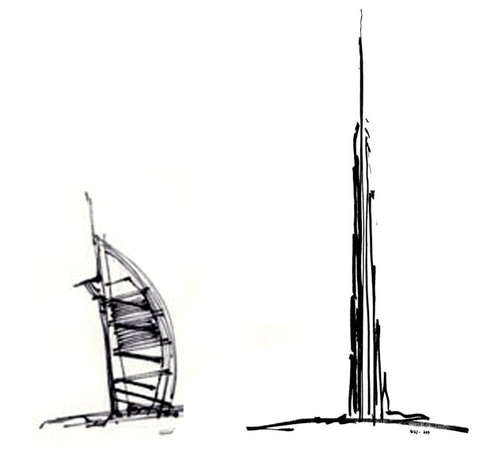
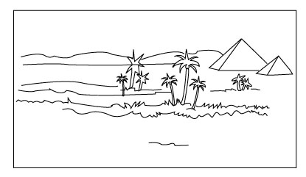

Picture 1 Picture 2

- ________________________________________________________________________

________________________________________________________________________

- ________________________________________________________________________

________________________________________________________________________

- ________________________________________________________________________

________________________________________________________________________

- ________________________________________________________________________

________________________________________________________________________

- ________________________________________________________________________

________________________________________________________________________

Part E. Writing Composition (worth 25 points)

25

Directions: Write a composition of 100-150 words on the following topic:
RAISING GETTING DRIVING LICENSE AGE TO 21
The authorities are thinking of increasing the driving age from 18 to 21. What is your opinion? Are you for or against?
You may cover these points:
- Reduce/increase accidents
- Be more responsible
- Job/college requirements
- State your opinion with reasons
تنظر السلطات في موضوع رفع سن الحصول على رخصة قيادة السيارة من 18 الى 21.
ما هو رأيك؟ هل أنت مع أو ضد هذا القرار؟
بامكانك الكتابة في النقاط التالية:
-خفض/زيادة نسبة الحوادث المرورية
-تحمل المسؤولية
-متطلبات العمل/الدراسة الجامعية
-اذكر رأيك مع توضيح الأسباب
________________________________________________________________________

________________________________________________________________________

________________________________________________________________________

________________________________________________________________________

________________________________________________________________________

________________________________________________________________________

________________________________________________________________________

_______________________________________________________________________

________________________________________________________________________

________________________________________________________________________

________________________________________________________________________

________________________________________________________________________

____________________________________________________________________
Good Luck ☺

