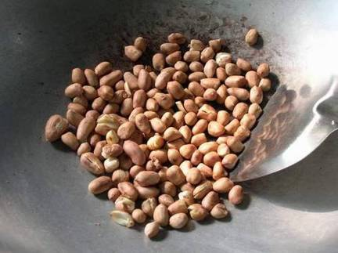

กว่าถั่วจะสุก งาก็ไหม้

The sesame was burnt by the time the beans were done;
You can't do both jobs well at the same time.,
You can't attend to one thing without neglecting the other

Supaporn Chunkla
Grade 7

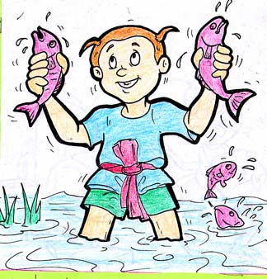

จับปลาสองมือ
Greedy. Wants two things at the same time
You may success nothing.

Somsak Kawsan
Grade 7

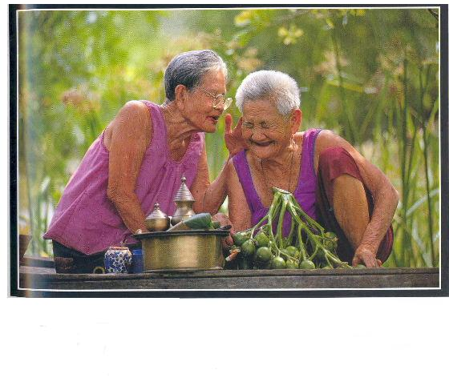

ความไม่มีโรคเป็นลาภอันประเสริฐ
Health is better than wealth.

Rujira Wongwai
Grade 7

