Festivals of Delhi
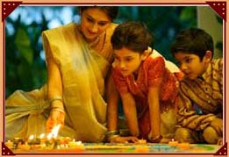

Delhi, being the capital of India, is home to people of all religions and communities from different parts of the country. The religious and state festivals are celebrated with pomp and show, wherever there is concentration of population from the same community and state. The major festivals celebrated in India are the Hindu festivals of Durga Puja, Diwali and Holi, Muslim festivals of Eid and Bakrid, National events such as the Republic Day, Independence Day and Gandhi Jayanti. Republic Day Parade is organized on the Rajpath, and is celebrated with great zeal and enthusiasm.
Lohri, a Punjabi festival, is celebrated annually on 13th January. It marks the end of winter and people arrange grand bonfire parties, wherein they dance and sing all night. On the very next day, Hindus celebrate Makar Sankranti. On this day, a Kite Festival is arranged every year in Delhi on the green lawns above Palika Bazaar at Connaught Place. The colorful kites of all shapes and sizes are beautiful to look at as national as well as international participants display their skills. Basant Panchami or the Spring Festival of Hindus is usually celebrated at the end of January or early February.
By:-

Gurleen Dhodi

IV A

