GRAND RELIGION
by V. V. Raman
Some say it was Krishna
Who came to save and please us.
Some think it was Buddha,
Yet others that it was Jesus.
To some, the Laws of Conduct,
To Moses God had said.
Some believe that God had spoken
Only to Prophet Mohammed.
Like the frog which was certain
That its pond was all the sea,
Everyone is slightly right
As far as he does see.
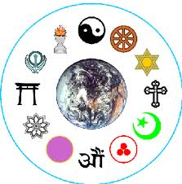
Our sun is surely brilliant:
None can this deny.
But does it make much sense to say
There's naught else in the sky?
If religious frogs just jump out
Into the big, big sea,
They'll know there's much more
To religious ecstasy!
Religions are volcanoes:
Powerful sure they are.
But they come from a much deeper Source
That's grander, oh by far.

