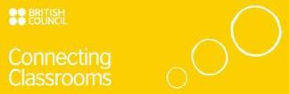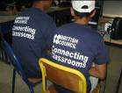

Curriculum Development: Connecting Classrooms
I was lucky enough in the week before half term to visit Morocco as part of the Connecting Classrooms initiative in partnership with Robert Mays and all primary schools within our pyramid. Along with Sue Rafter, the Headteacher at Robert Mays School, Linda Platt, Headteacher of Greenfield’s Junior School and Sue Marsh, language coordinator at Robert Mays and group leader, we set off to Beni-Mellal, Morocco, for a week, to experience their culture as well as visit schools in the local area to determine how our current curriculum can benefit from the link.
In the school’s entrance hall, a display of photographs, maps and letters shares some of my experiences and is the starting point for the development of connecting classrooms!

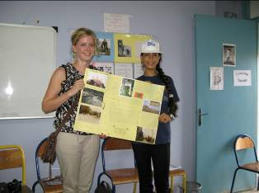

What is Connecting Classrooms?
Connecting Classrooms is a global programme that creates partnerships between clusters of schools in the UK and others around the world. These partnerships bring an international dimension to young people’s learning, to improve their knowledge and understanding of other cultures and prepare them for life and work as global citizens.
Robert Mays School and cluster Junior and Primary Schools bid for Morocco to form a partnership back in 2009. The bid was successful and the schools received a grant to develop links between Hampshire schools and schools in Beni-Mellal, Morocco. Last year the Moroccan cluster leader, Ahmed Mouhy-dine, visited all of our cluster schools, talking to the children during his visit and kick-starting the partnership.
As part of this grant, teachers from Hampshire had the opportunity to visit Morocco to establish stronger partnerships with their Moroccan teachers and to visit the children who are part of the project. In return, the Moroccan teachers will be visiting our schools in February 2012.
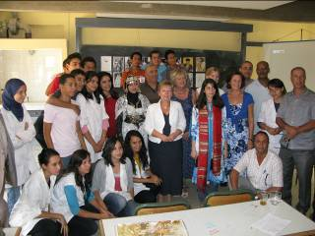
What was the focus of the week?
The key aims of this exchange visit were to meet the coordinators of the Moroccan schools involved in the project face to face, to visit pupils in their classrooms, to meet key stakeholders linked to the Ministry of National Education and to keep up regular contact between the two clusters and reinforce their partnership more closely.
In addition to that, the Hampshire cluster learned about the culture, customs and traditions of their Moroccan counterparts, through the presentations, songs and shows presented by Moroccan pupils from state schools. The cluster visited private schools as well in order to have a clear overview and understanding of the educational system in both private and state sectors in Morocco.
The exchange visit left positive impressions and impact on both teachers and pupils visited. It was an excellent opportunity to establish stronger links between the two clusters, keeping the project two-sided and sharing the experiences and best practice to forge ahead the partnership for the next year.
Overall, the visit was of great benefit to both clusters. Moroccan pupils were very excited about the project in general and the visit in particular. Pupils have shown greater motivation and commitment to the project when visited by the Hampshire group.
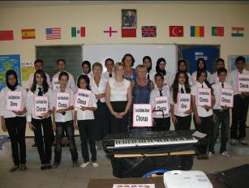

What are the benefits for children at Hook Junior School?
One of our key improvement areas in the school strategic plan this year is SMSC (social, moral, spiritual and cultural) education. In broad terms, this development looks to embed different aspects of each SMSC area within the current curriculum, as well as providing links to PSHE and RE. SMSC looks at the guiding principles of a productive society, developing in the children a sense of pride, of respect, inner confidence, a sense of community and well being and an ability to take on the challenges of an ever-changing world on top of the capabilities to be literate, numerate and develop skills, knowledge and understanding of other curriculum areas.
Connecting Classrooms offers a unique opportunity to develop an understanding of another, very different, culture in very real terms, making connections with real children living their own lives. This will help the children to truly respect other cultures, and indeed, other religions which are quite different from our own, breaking down barriers and stereotypes that are all too common.
Similarly, it will provide purpose for some of their work, and in particular writing, where the children can create pieces of work, in English and French, that can be shared, through letters, parcels, ICT and video links. Many of the children in Morocco are learning English and it will be a fantastic opportunity to provide information and stories in English and develop their own language skills in French.
Next steps
With this in mind we have begun planning activities for the children to begin our international partnership. By Christmas the children will have produced work to share with our Moroccan partners, such as poems, stories and artwork that describe our culture, traditions and experiences. This will focus initially on where we live – what is Hook like? What can we see from our classroom or bedroom window? What is our day like? And so on.
After Christmas we will be looking more closely at religious differences, holidays and festivals as well as exploring each other’s climate and landscape. This will provide real opportunities for the children to ‘live’ through the year alongside a different religion, with festivals and celebrations shared and understood across the two countries.
We will also be hosting our Moroccan teachers for a morning and will be sharing some work, presentations and music with them. I know from having met them that they are very excited to see our children and to share some of their own work, as well as take their new experiences back to their classrooms.
The work will predominately be shared through the elanguages webpage, where the children can upload work, videos, sound clips and photographs to share with the Moroccan schools. This can be viewed at: http://www.elanguages.org/126311
We also hope to make a strong link with a focus school so we can send cards, posters and children’s work, as well as share experiences of what we do for our festivals, such as Christmas and Easter. Our Moroccan partner school will do the same, so we can have an experience of their celebrations such as Ramadan, Eid-ul-Fitr and Eid-ul-Adha.
We are very excited at this unique opportunity to really link up with schools in Morocco. It is such a wonderful country, very different to ours yet full of similarities. Through this work with connecting classrooms, we hope to develop international links to break down stereotypes and form global friendships.
Caroline Baron
Assistant Headteacher
Curriculum Leader

