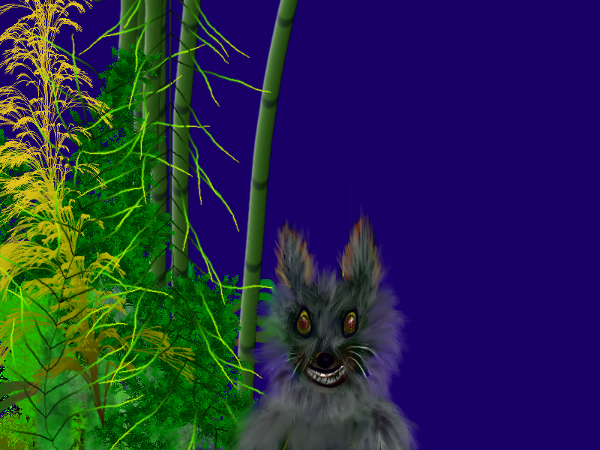

The Cunning Wolf
It is an interesting story from the collection of Jataka Tales. Once upon a time, some people from a certain town went into a forest for an excursion. They want to enjoy the holiday to its fullest. They took baskets full of eatables with them. They ate all the meat they had brought with them till the noon time. They didn’t leave anything for the dinner and suddenly realized that what they would eat in the dinner. They wanted to enjoy the vacation and without proper food, it was quite impossible.
One of the men said, “There is no need to worry. I will bring some fresh meat. We will make a fire here and roast it. It will be a great fun too”. After saying this, he took a club and went to the lake. He knew that the animals would definitely come to the riverside for drinking water. He lay down on the ground with a club in his hand and pretended as if, he was dead.
After some time, a group of wolves came down to the lake. When they saw the man lying on the riverside, they kept an eye on him for some time. The King of the wolves said, “I think, this man is playing trick on us. All of you stay here, while I will go and check whether he is really dead or pretending to be dead”. So, the cunning king of the wolves slithered up to the man and pulled his club a little cautiously. The man pulled back his club at once.
The King of the wolves ran from the place and shouted, “If you had been dead, you would not have pulled back you club when I tried to pull it. I caught your trick. You pretended to be dead so that you may kill one of us for your dinner”. The man quickly jumped up and tried to kill the wolf. He chucked his club at the King of the Wolves. Unfortunately, the man missed his aim and the wolf safely ran away. He looked for the other animals, but none of them was visible. All of them ran away.
The man got frustrated at this, but could not do anything. Thus, he went back to his friends and said, “I tried to get fresh meat by playing a trick on the animals, but the cunning wolf played a better trick on me. I am sorry. I could not get fresh meat for you”.

