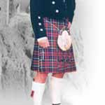
Scottish Traditional Dress

This is a Scottish kilt; these are mostly worn at weddings.

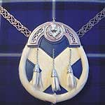
Scottish Satire Flag Sporran with a flag front.

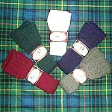
Kilt Hose
Embroidered Hose Finest quality wool Blend Kilt Hose. Ribbed leg section and Thistle emblem embroidered on turn over top. Hercoset treated to prevent shrinkage. Coloured Hose Finest quality wool rich Kilt Hose. Ribbed leg section and patterned turn over top. Hercoset treated to prevent shrinkage

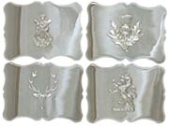

PLAIN BUCKLES
A selection of four embossed designs to choose from

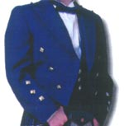
The Prince Charlie is a formal jacket typically worn at evening functions and formal events. Barathea pure wool. Please refer to our sizing chart.

