My free time

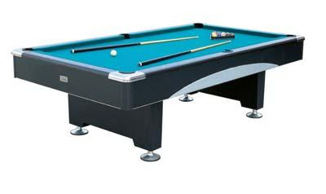
In my free time I go out with my friends down the street and at the youth club behind Kennoway shopping centre. At the youth club we listen to music and play pool. I listen to music and sleep a lot. Some times at the weekend I go shopping and get new stuff like clothes. On a Friday night I go down the street and hang about with some of my friends.

