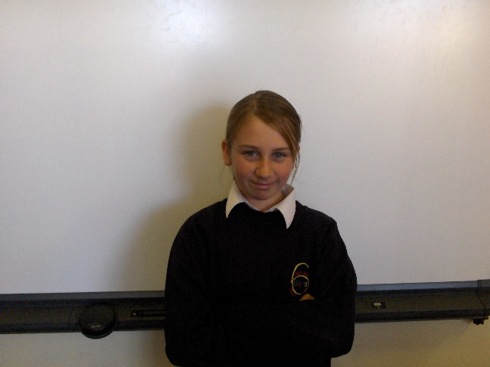

Hello my name is Alice Slater and this is my school day.

In the morning I get up at 8:00 o’clock and eat my breakfast till 8:15 I get changed and have a wash and brush my teeth and at 8:30 I set of to school. I arrive at the school at 8:45 and take the registers.

In the morning

In the morning we have maths first thing for an hour with Mr. Holden. Then we have brake 15 mins. After brake we
Have English for an hour sometime its fun.

Dinner time:

At dinner time we have and hour to play outside I have to take the registers with Leah. Then we go in for dinner you can have sandwiches or school dinner’s im sandwiches. Then I play out with my best mate Jennie. Then the bell goes and we have science and i.c.t.

Friends

- Jennie
- Terri
- Tia
- leah

