My typical school day
Our names are Laura and Jade. On a morning we get up at 8am and have a wash. We then go downstairs to eat our breakfast, we usually have coco rocks. We then go upstairs and get dressed into our school uniform. After that we set out to school at about half past 8.we arrive at school at about quarter to 9 and the bell rings. Our first lesson has begun.

Our first lesson is usually Maths. In Maths we learn about shapes, addition, subtraction, division and multiplication. We have Maths at 9am and finish about 10am but on Thursdays we start at 9am and finish at 11am.

After Maths we have our break, which is normally fifteen minutes long. During break we can talk with friends, eat our food, annoy teachers, play games and play football.
Then at 10:15am the bell rings and we go inside for our next lesson.

Our next lesson is normally English. In English we write poems, do work from books and writing story features. Then at 12:15pm we have lunch, which lasts for 1 hour. During this time, we eat our lunch, chat with friends and play more football. At 1:15pm the bell rings again and all the children walk inside for their last lessons of the day.

For the last two lessons of the day we do our theme work. This involves doing work on a book we have been reading called Michael Morpurgo’s Kensuke’s Kingdom.
During this lesson we can do writing about the book and make different things with different fabrics and materials.

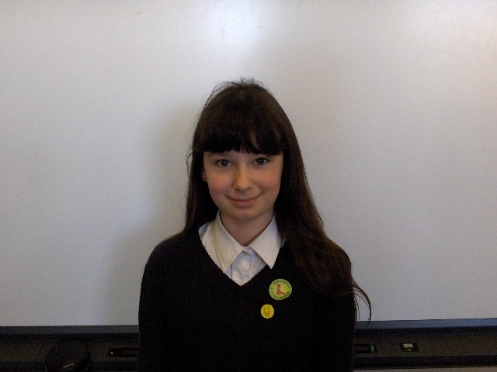
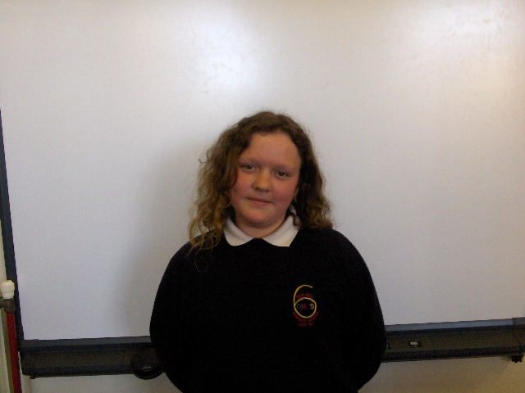
Then at 3:15pm we leave school and head for home. That ends our typical school day.

This is Laura This is jade

