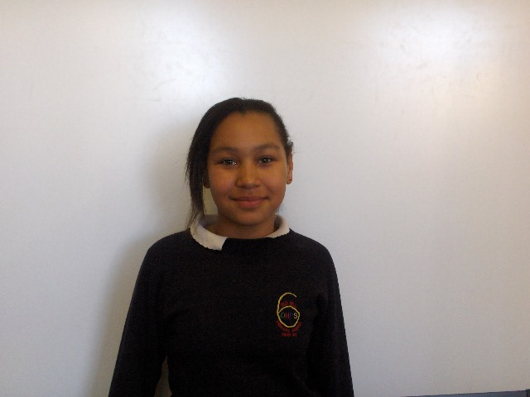
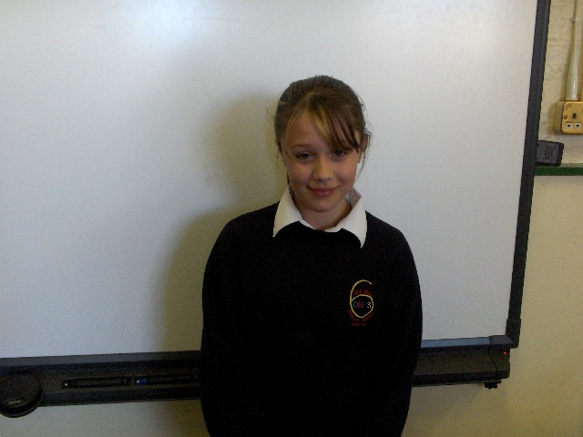

This is me Leah and This is me Tia

Hello we are pupils at Old Hill Primary School and this is our typical school day…

Tia

Hello, first I will start of with my typical morning. My mom wakes me up at about half-past seven, but I normally get up about quarter two. I then get dressed and go to the bathroom.
I go down stairs and my cup of tea will be waiting for me on the coffee table and the television will be on ready for me.

At about quarter past eight my friends will be waiting for me outside of my house, we then walk to school it takes us about 3 minutes to get to school.

We come to school and sit in our normal seats; our teacher then takes the register.
We always have the same teacher for every subject except from maths we then have a different teacher.

Our first lesson is maths by a teacher called Mr Holden we learn all sorts of things here are some examples…
- Number pyramids
- Digital root
- Square number

And loads more…

We do a mixture of activities and lessons in the day.
We then finish school at 3:15, I then start off back home.

Leah

Hello I will get up in the morning and go down stairs my mom will then do me some breakfast and a cup of tea then I will get changed and brush my teeth then my mom will drive me to school.

The bell then goes at five to eight and finish school at 3:15 and through them hours we do a lot of lessons such as…
- Maths
- Literacy
- Topic work
- Science
- Sometimes art or technology
- And others

We also have a break time and a lunch between them hours.

