Our Life in old hill primary School

HI.
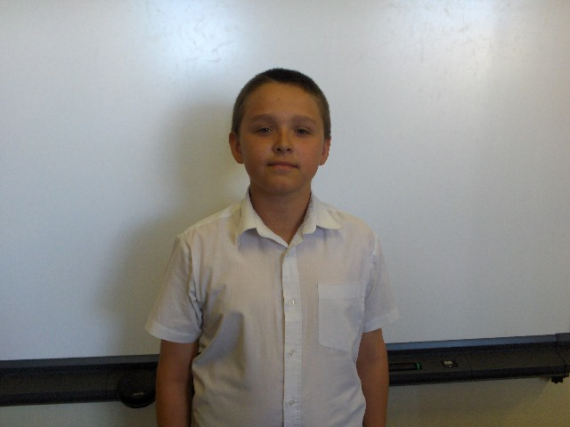
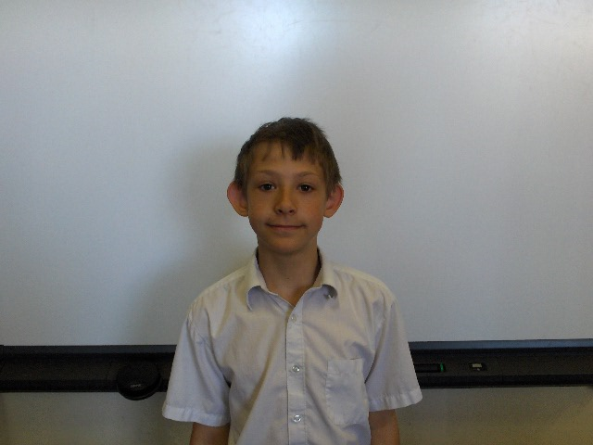
This is about our life in old hill our names are Ricky Steadman-> and Matthew Freeman.->

This is what time Matthew wakes up 7:00am. This is what time Ricky wakes up 7:15am.

Before school Ricky has a wash and then gets dressed and goes to school and so does Matthew

When we get to school we do maths for 1 hour sometimes 1 hour and a half after that we have break

