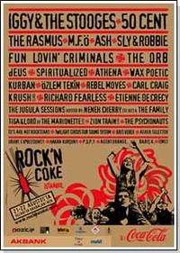
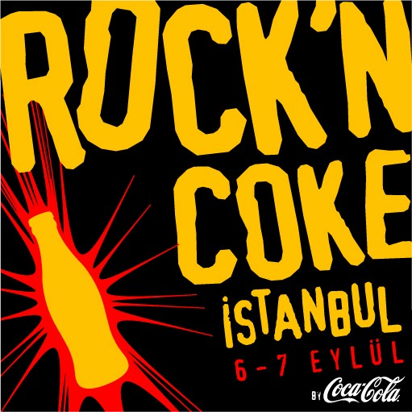
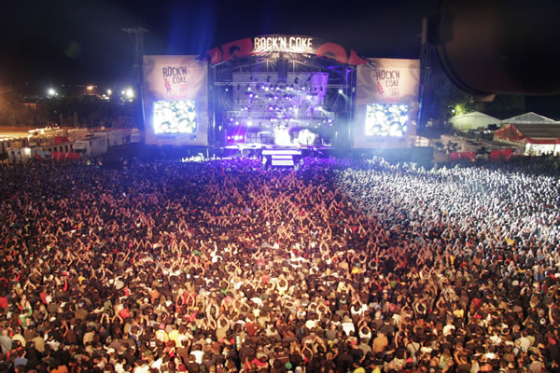
ROCK’N COKE!!!

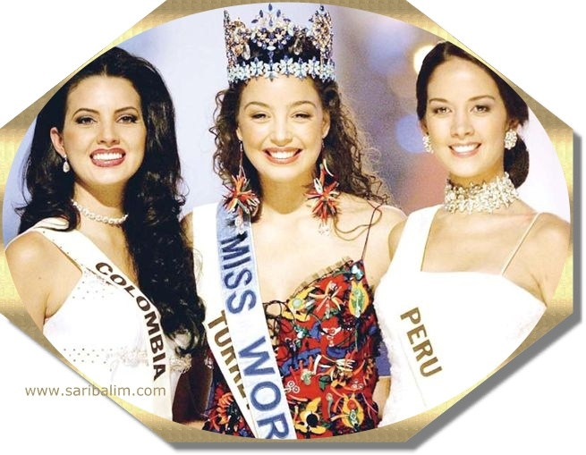

Rock'n Coke is a Turkish rock festival sponsored by Coca-Cola. It is traditionally held at the Hezarfen Airfield in İstanbul TurkeyThe Festival
Rock'n Coke is a member of the European Festival Association. The festival is organized by the Turkish concert organizer Pozitif. At the end of every summer, the Hezarfen Airfield is used as a venue for a two day chain of concerts, with both national and international performers featured.
Although mainly rock-oriented, Rock'n Coke also hosts other music genres. While the main stage is generally reserved for rock and its subgenres, the DJ Arena (now called Burn Stage, following the sponsorship) is reserved for styles such as house music.
In 2005, the festival grounds were large enough to support two stages, a mini-amusement park, two large food areas, a shopping area, several sponsor

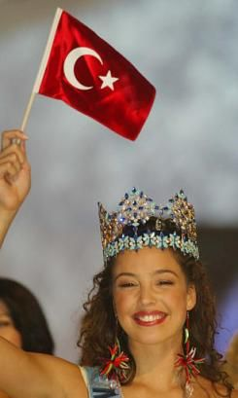
Azra Akın is a Turkish model, who crowned Miss World 2002 at the annual pageant held on December 7, 2002 at Alexandra Palace in London, England, representing Turkey.
She was born on December 8, 1981 in the Dutch town of Almelo, and was raised in the Netherlands by Turkish parents.
Akın enjoys ballet and plays the flute. She also won the pageant's Best Gown award. At 17, she was selected Elite Model Look 1998 of Turkey.
In 2003 she won a gold medal when she participated in the British reality TV show The Games.

__MISS WORLD OF 2002__

