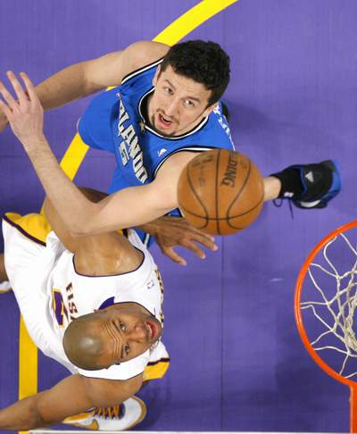
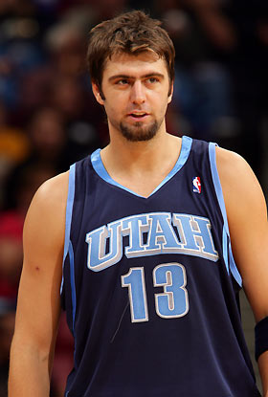
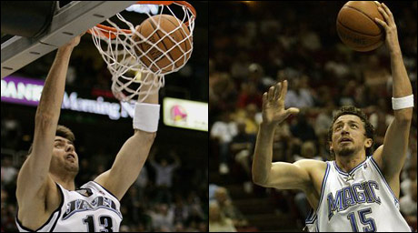
Hidayet Türkoğlu, sometimes referred to as Hedo Turkoglu (born March 19, 1979, in Gaziosmanpaşa, Istanbul, Turkey), is a Turkish professional basketball player, and the first Turkish-born player in NBA history.
He stands 6 ft 10 in (2.08 m) tall and plays the small forward position. He is a solid shooter inside and outside the three point line. He is a versatile player who has played four positions from point guard to power forward during his career.
Before coming into the NBA, Hidayet cited Kobe Bryant, Grant Hill, Scottie Pippen, Allan Houston and Latrell Sprewell as his favorite players.^{[1]} He was selected with the 16th pick by the Sacramento Kings in the first round of the 2000 NBA Draft from one of Istanbul's and Turkey's top clubs, Efes Pilsen.
He was a finalist for the NBA's Sixth Man of the Year Award in his sophomore season after averaging 10.1 points per game, 4.5 rebounds per game, and 2.0 assists per game coming off the called Hido Menu in Turkey during the first years of his NBA career.^{[2]}

Mehmet Okur (born May 26, 1979 in Yalova, Turkey) is a Turkish professional basketball player who currently plays for the Utah Jazz of the NBA.He was named to the Western Conference All-Star team for 2007 NBA All-Star Game. He and Ray Allen were selected as replacements for injured original members Allen Iverson and Steve Nash.[10] He is the first Turkish player to participate in this event.He is married to former Miss Turkey and model Yeliz Çalışkan, and they have a daughter, Melisa, born on March 21, 2007.

