Inter-Action: sections européennes and specialist schools
Annual Partnership Conference, Sèvres, 17-18 January 2008
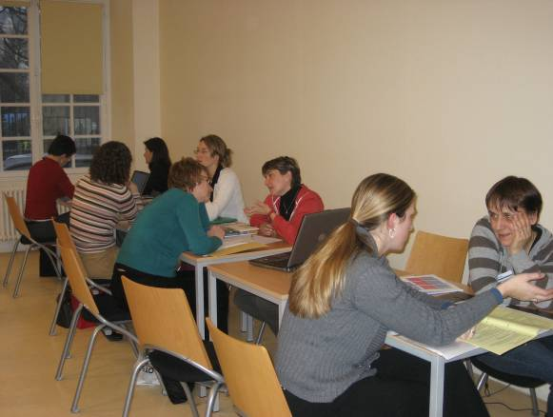
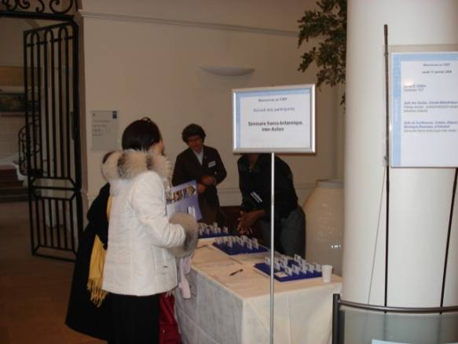
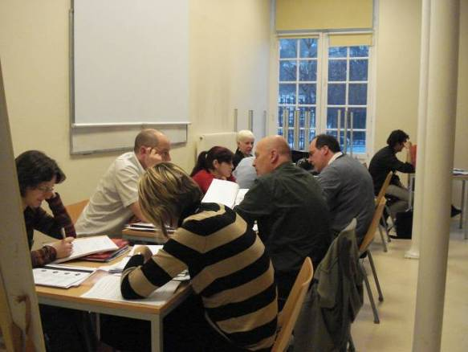
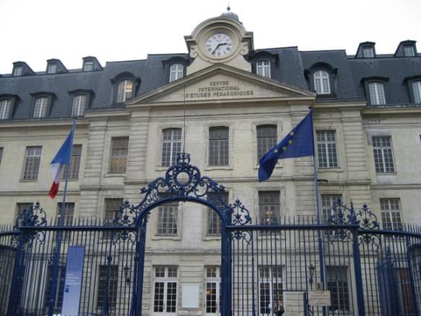
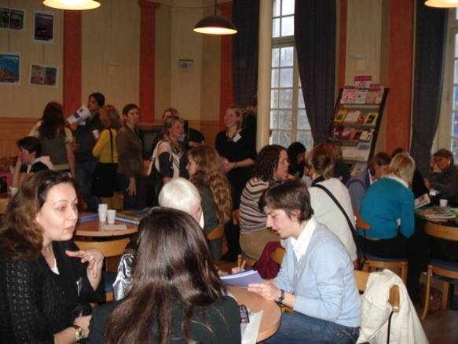
Centre international d’études pédagogiques (CIEP), Sèvres
Registration
Coffee, croissants and meeting partners
Planning with partners

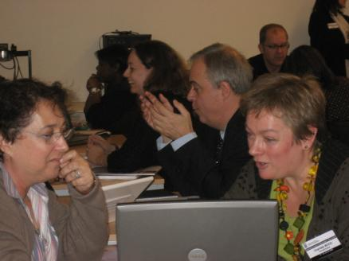

Planning with partners
Charlotte Wood (right) and Pascaled Beau Iman (left) planning together

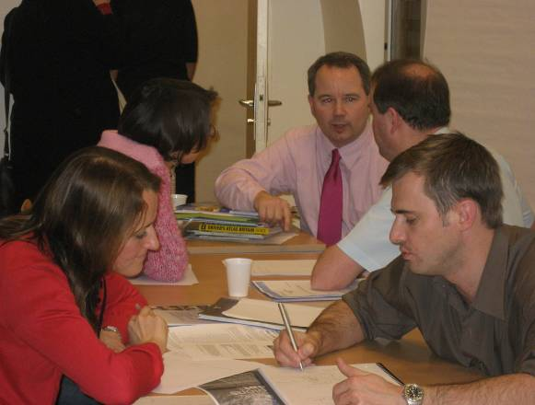
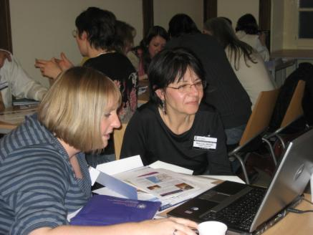

Planning with partners
Planning with partners

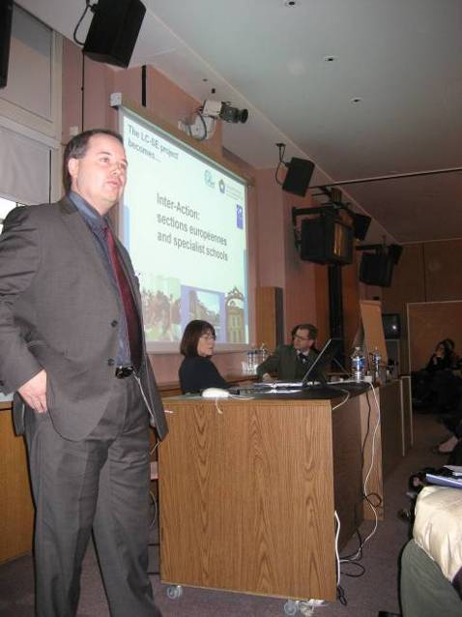
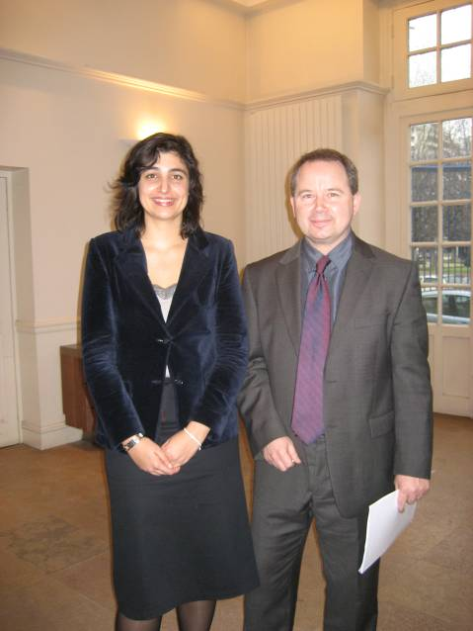

Adrian Ash, National Programme Coordinator: International
Caroline Rossi (CIEP) & Adrian Ash
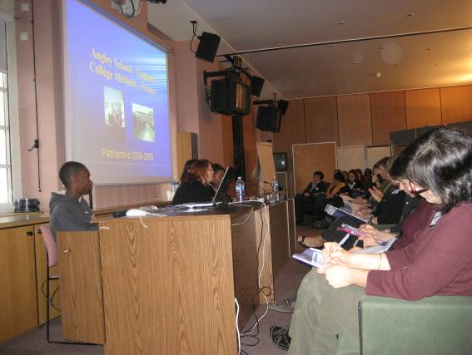
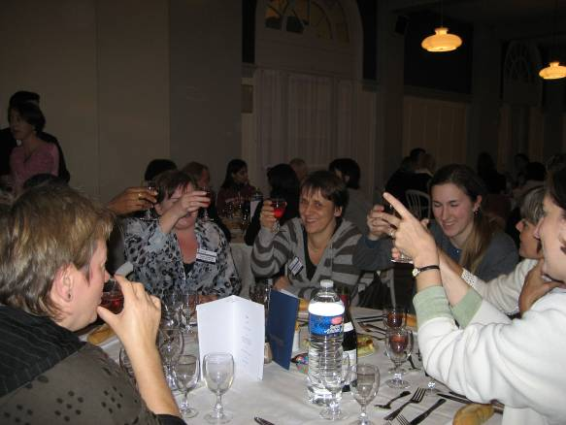

Presentation by Collège Edmond Michelet
Charlotte Wood (left) and French colleagues, evening meal, CIEP

