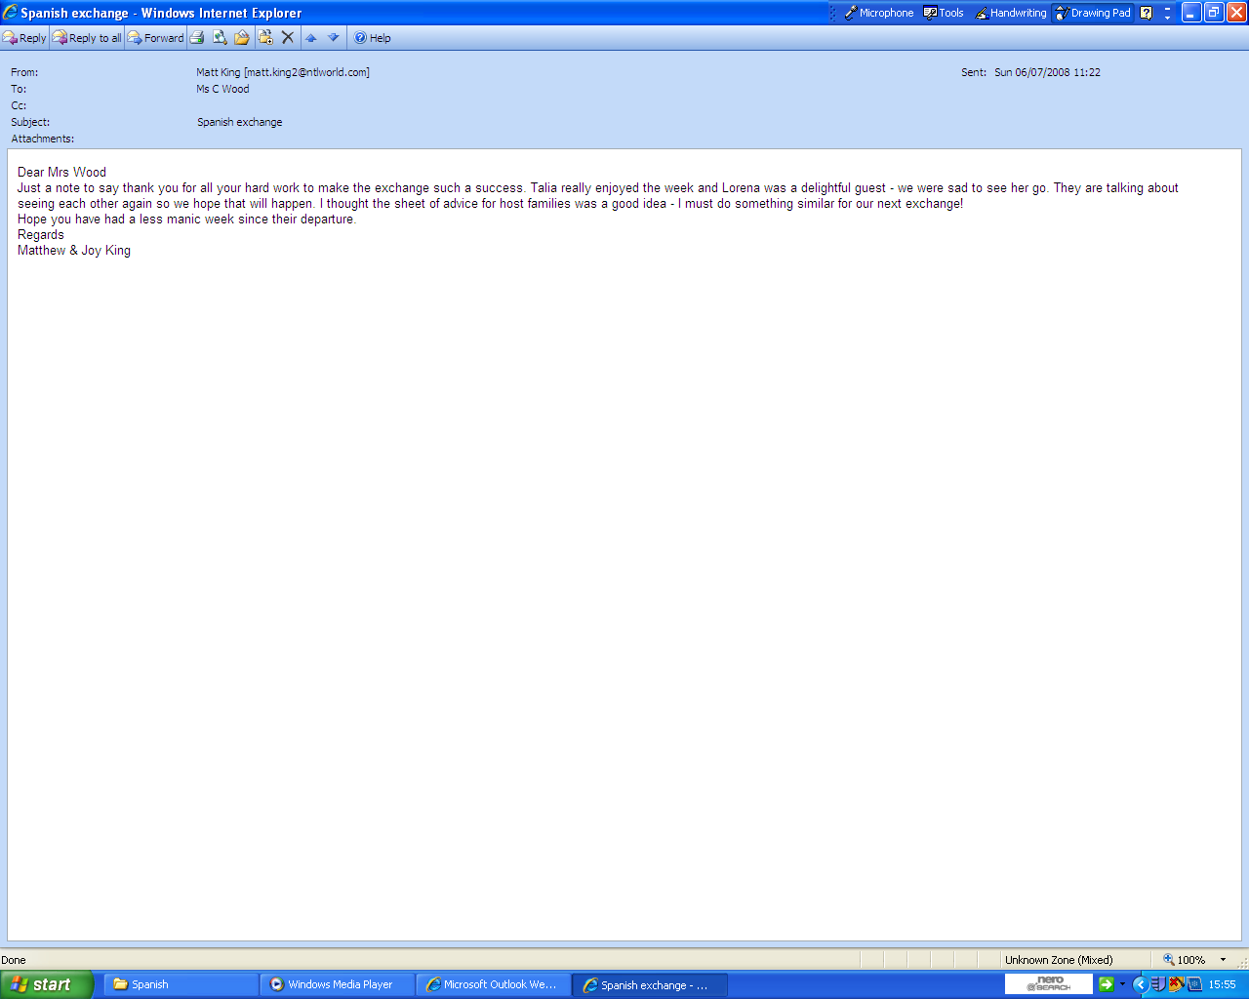
Parental evaluation for Spanish Exchange

