Bulgaria Comenius Trip

On the 4th May 2008, six year 8 and 10 students with 2 teachers set off a Balkan adventure. We left the Holt school at 6:30 am. Despite our fears, we sailed through terminal 5 with no problems and retained our baggage!
When we first landed we were surprised at how many hills were around the airport. Some of the mountains in Sofia were covered with a lot of snow even though it was still extremely hot.
Once we had met our host and the Italians, Bulgarians and the French students, we piled onto the rickety Bulgarian coach and made our way to Pleven which was another 2 hour drive. On our journey we passed through the beautiful valleys and forests of Bulgaria and had our first encounter with Bulgarian driving.
As visions of a 4 star luxury hotel were in our weary head, we arrived at the military club hotel where we certainly got a surprise. On entering the rooms we realised a bed was missing in each room. However being informed by Miss Palmer and Ms Payne that there was no mistake and we were sharing bed between 2(all of us).But there was nothing to complain about as we still had a television, air conditioning system and most of us a balcony. We dumped our bags and headed off for some tea.

For the next three days we went sight-seeing, where we were set tasks in groups and also made our first visit to the school.
Thursday 8th May was the day we had the most amazing experience. We started of the day by visiting the school where we had a couple of lessons. After sitting through an outstanding music lesson we were leaded to a big room where a couple of presentations were presented and where we were taught some traditional Bulgarian dances. The Bulgarian school was so much different to our school as it was kept plain and bland. There were no displays and furniture was kept simple.
Most mid afternoons to early evening were spent by 2 hours shopping and visiting local places such as parks and museums. One afternoon we were taken to a pottery studio where we created some traditional clay pots.
That evening was really enjoyable as we were taken home by some Bulgarian students for dinner. The houses were much more modern than English houses and we were treated with many dishes of traditional food.
Overall our tiring week in Bulgaria was the most terrific experience in our lives as we learnt so much about the culture and traditions of Bulgaria.

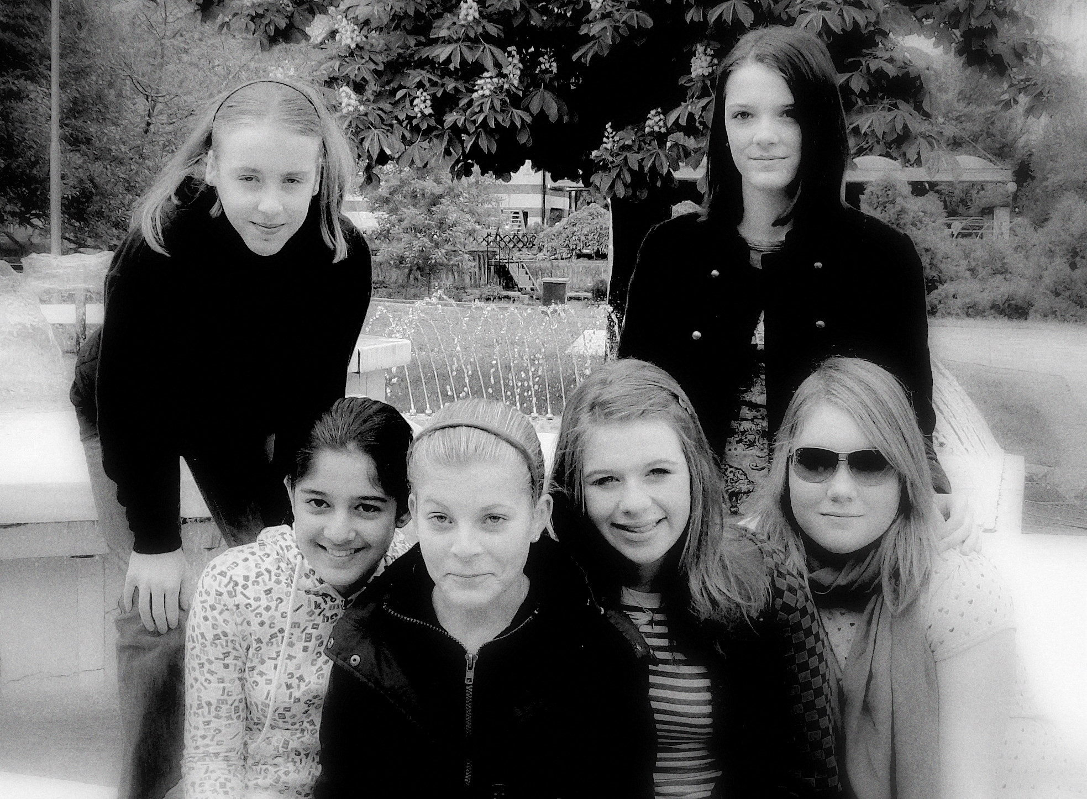
By Lubiana Shabeer 8T and Ms Payne

