Year 8 Cross Curricular Homework Project 2008

Monday 23rd June – Friday 11th July


Name | Form

AIM
The aims of this homework project are -
- To set you a challenge
- To develop your study skills
- To use your homework time so that you can concentrate on one task at a time, with all tasks having a common theme
- To give you some choice

This project will replace homework in those subjects participating for three weeks in the Summer Term of 2008 - English, Geography, History, Languages, Art and Maths. You will also be set homework as normal by other subjects.
Outline of Tasks

Beijing Olympics 2008
Task Number | Subject | Task
1 | Art | Designs using the famous Chinese ‘Willow’ pattern.
2 | English | A chance to use your creative skills as a journalist or competitor.
3 | Geography | A fact finding mission about China and the impact of the Olympics.
4 | History | A chance to explore the origins of the Olympics and find out about some of its modern day heroes.
5 | Maths | Presenting and analysing data about the number of medals awarded in the last three Olympic Games or investigating the cost of a family trip to China before and during the Olympics.
6 | Deutsch | Using German magazines and websites to find out about sports personalities from Germany, Austria or Switzerland.
7 | Espanol | Exploring Spanish competitors in the Olympic Games past or present and presenting your findings in Spanish
8 | Francais | Presenting information about a famous French athlete and producing an article about them in French
How will my work be assessed?

- You will complete a self assessment sheet in the final week, which you will put in your folder as the final page. There is a space for your parents to write a comment if they wish.
- Subject staff may mark your work or ask to see the task for their subject e.g. Languages where they will need to correct any mistakes.
- A team of teachers will look through everyone’s final project to award general effort and achievement.
- Sixth formers will be carrying out two checks to make sure you are managing your time well.

What will my final work look like?

You have some choice:
You may either complete all your work on line and submit via your homepage on the school website or hand in a folder containing all the pieces of work you have produced. Keep this on you at all times. Your form tutor will give the folder to you with this booklet. There will be a separate session on how to submit your work via the website. You should not do a mixture of both on line and folder work – one or the other only is allowed.
Your work can be handwritten or word-processed or a mixture of both.

Where can I get help if I get stuck?

- Your form tutor if you are having problems sticking to the timings.
- Your teacher if it is about a subject task.
- Project Homework club – Thursday 3.30-4.30pm
- Mrs Barry or Mrs Smith
- The school website also has a copy of the tasks.

What if I don’t have a computer at home?

- T7 and ICT Room will be available most lunchtimes.
- You are welcome to come to Project Homework Club on a Thursday afterschool.

PLANNER
We suggest that you spend 1-1 ½ hours a night on your project homework. To guide you through the tasks you should follow this planner. Each night write down how long you spent on each task. Your subject teachers have a copy of this and will know when you should be working on their task.
 | Task | Time you spent | Other Info
Week 1
Mon 23rd June | Art
Tues 24th June | Art/English
Wed 25th June | English
Thurs 26th June | English/Geography
Fri 27th June | Geography |  | Check 1
Week 2
Mon 20th June | History |  | Check 1
Tues 1st July | History/Maths |  | Check 1
Wed 2nd July | Maths
Thurs 3rd July | Spanish or German
Fri 4th July | Spanish or German/French
Week 3
Mon 7th July | French |  | Check 2
Tues 8th July | Catch up! |  | Check 2
Wed 9th July | Catch up! |  | Check 2
Thurs 10th July | Print, finish off and do front cover! (and put in my bag!)
Fri 11th July | DEADLINE FOR HANDING IN TO FORM TUTOR  (Hand in either folder or completed information sheet for your project to be marked online)
Week 4
Tues 15th July | Teacher assessment of all projects to award effort and achievement.
Thurs 17th July | Presentation Assembly – Prizes and certificates

TASK 1 - ART

Time allocated to this task | 1 ½ hours



HOMEWORK TASK
- Willow pattern plate design. Research willow pattern designed by Thomas Minton in 1790. Find out about the story behind the pattern.

- Draw a willow pattern plate

- Design and colour a willow pattern style plate that represents your own life/interests/achievements.



TASK 2 -ENGLISH
Time allocated to this task | 3 hours

HOMEWORK TASK
Hello, Year 8! In English, we are really looking forward to reading what you are about to write and our aim is to give everyone a chance to excel, so just be ready all you creative geniuses!

You have a choice of three tasks, all of which relate to the theme of the Olympics.

Spend time looking at these options and research where necessary. Feel free to seek advice from your Teachers and make an informed decision based on a balance between fun and pushing yourself to the next level (just like Paula Radcliffe in the London Marathon). ☺

- It is estimated that the 2012 Olympics in London will cost £5.3 billion! Is this cost justified and who, if anyone, will benefit? Write a feature article exploring the arguments for and against this expenditure.
- Using your journalistic skills, write an article about the 2012 Olympics in London.
- An Olympic fable: create your own tale about an unexpected hero/heroine who has achieved against the odds (like Eddie the Eagle or Oscar Pretorius, the athlete with prosthetic legs). Remember, it must have a moral to it.

Please start thinking and begin to gather resources now; your Teacher will also have materials to show you in lessons.

TASK 3 - GEOGRAPHY

Time allocated to this task | 2 hours

Imagine that you are a competitor in this year’s Beijing Olympic Games. These tasks will give you the opportunity to learn about China and Beijing,
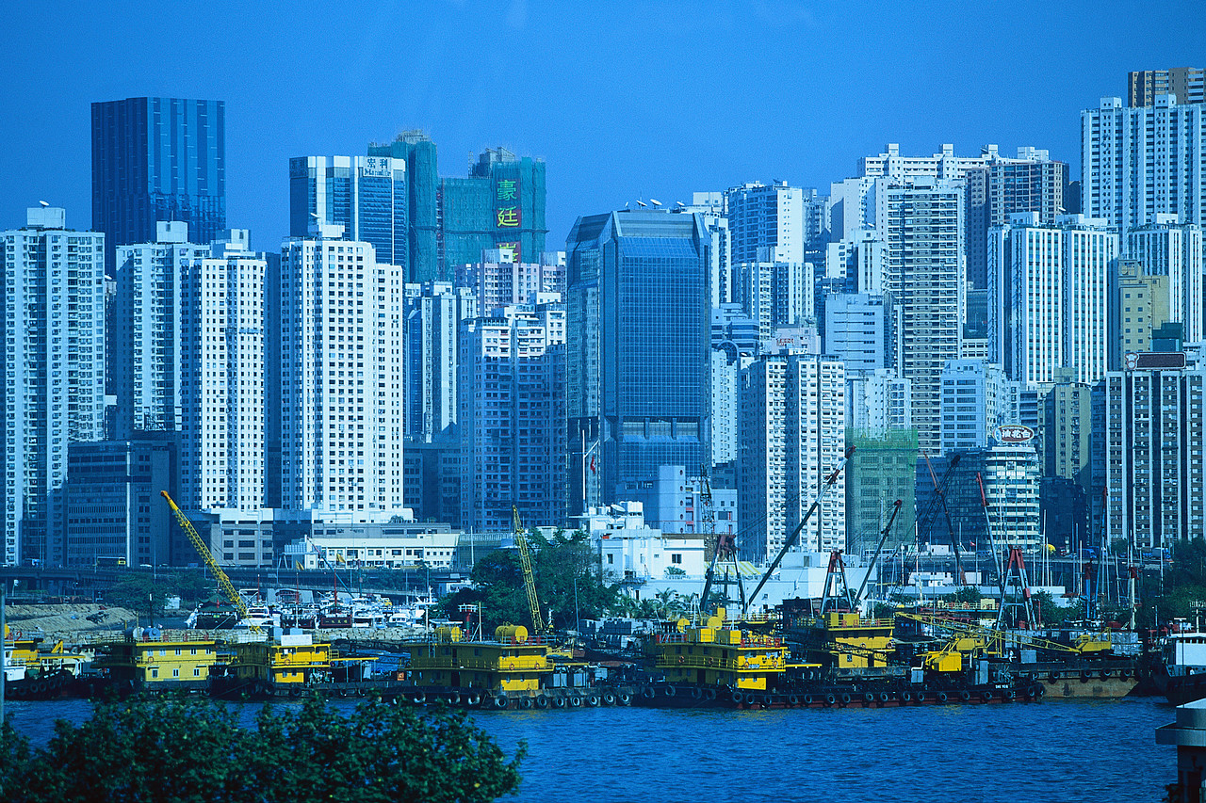
Activity 1
- ON the map of China -
  - Label the main cities
  - Label the rivers
  - Label four of the countries that surround China.
  - Label the South China Sea
  - Label Hong Kong
  - Label the Himalayas and Mount Everest

- Produce a Fact File about China which must include the following –
- Population
- Currency
- Language
- Flag
- Main religion

- How will you get to the Olympic Games?
Describe in detail your journey to Beijing e.g. method of travel, airports etc
Activity 2
- Write a letter or a (large) postcard home from Beijing describing city life.
Include information and pictures about some of the following - food, transport, lifestyle, housing, customs, environment, entertainment etc.

If you need help please ask your Geography teacher. Remember you should only spend 2 hours on this task.

TASK 4 -HISTORY

Time allocated to this task | 1 ½ hours
You have a choice of 2 tasks; research the ancient Olympics or a modern Olympic athlete. Read the instructions below:

OPTION 1
Every 4 years, elite athletes originating from the 4 corners of the globe, compete in what we call “The Olympic Games”. This year’s Olympics are being held in China. The modern Olympic Games were introduced in 1896. But the story of the Olympics stretches far into the ancient world. Your history project is to research the ancient Olympics and to produce either a newspaper article or developed answer focusing on the ancient Olympics (not modern games!).
Find out the truth about our Olympic past by focusing on the main areas outlined in the box below. The best pieces of work are the ones that are well organised, well presented, original and factually accurate.
What is the history of the Olympics? When did it start and how many years did it last?
Whereabouts were the Original games held and how often?
How are the ancient Olympics different to the modern Olympics?
What events did they have in the original games? What prizes did the victors win? What buildings did they have at the original site of the games?
What happened at the start and end of the ancient games?
Why were the ancient games stopped in the year 393AD?

OPTION 2
Or you can choose to research a famous Olympian from the modern Olympics.
Choose one from the following list:
Jesse Owens (1936) Daley Thompson (1984)
Cathy Freeman (2000) Dame Kelly Holmes (2004)
Michael Johnson Cassius Clay (1960)
What was special about them? What events did they compete in? Why are these people considered among the greats of the Olympic games?

TASK 5 - MATHEMATICS

Time allocated to this task | 2 hours

HOMEWORK TASK
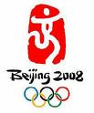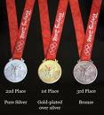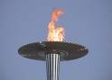

There are two tasks below, of which you must select and complete one.
Option 1
This task is about analysing and presenting the data. You need to investigate the number of medals (gold, silver and bronze) won during the last three Olympics. Your data only needs to cover the medals won by the top ten countries in the medal table. You should use pie charts, bar charts, spreadsheets etc to present your data.
Finally, investigate to find a link (correlation) between the number of participants and the population of a country or the number of participants and the number of medals.
Option 2
You need to investigate and compare the costs of a holiday for a family of four to China during the Olympics and after the Olympics. Your costs could include:

Flight costs by different airlines / Spending money / Excursions / Trips out / Hire of equipment and specialist clothing / Travel to and from airports, stations, ports / Car hire and petrol / Meal


TASK 6 - DEUTSCH

Time allocated to this task | 1 ½ hours

HOMEWORK TASK
- Research famous German speaking sports people. They could have taken part in the past Olympic Games, or be going to the games in Beijing this summer. They can be from Germany, Austria or Switzerland.

- Choose one person, and find out more about them. If you can find this information on German websites, that would be better. The German magazines which we subscribe to also have had features on famous sports people. You will find one reference copy of the editions in the library, and one in the Languages Department.

- Present your findings in German on that person. This can be written in the form of an interview, or a news page, a straightforward description or a poster. You can include photographs and pictures.

- Use the helpsheet provided to guide you./tmp/in/input.doc

TASK 6 - DEUTSCH HELP SHEET

Name: Er/Sie heißt …………

Geburtsdatum: Er/Sie hat am………Geburtstag

Geburtsort: Er/Sie ist in ……… .geboren

Haarfarbe: Er/Sie hat (hatte) ………Haare

Augenfarbe: Er/Sie hat (hatte) ………Augen

Familie: Er/Sie hat (hatte) ……………

Er/Sie ist berühmt für …………………………

Leistungen (achievements) …………………

TASK 7 -ESPAÑOL

  Time allocated to this task | 1 ½ hours

HOMEWORK TASK
- Research famous Spanish speaking sports people. They could have taken part in the past Olympic Games, or be going to the games in Beijing this summer. They can be from Spain or any of the other countries around the world where Spanish is spoken.

- Choose one person, and find out more about them. If you can find this information on Spanish websites, that would be better. Your text book also has some profiles of famous sports people. The Spanish magazines which we subscribe to also have had features on famous sports people. You will find one reference copy of the editions in the library, and one in languages.

- Present your findings in Spanish on that person. This can be in the form of an interview, either acted out and filmed, or recorded, or written down. It could also be a Powerpoint presentation, a poster, or a straightforward written description. You can include photographs and pictures. Minimum 150 words in full sentences – no bullet points

- You will find a writing frame and some useful phrases on the website Year 8 page./tmp/in/input.doc

TASK 8 - Français

Time allocated to this task | 1 ½ hours

HOMEWORK TASK
- Research famous French speaking sports people. They could have taken part in the past Olympic Games, or be going to the games in Beijing this summer. They can be from France or any of the other countries around the world where French is spoken.
- Choose one person, and find out more about them (name, age, where they live, hobbies, famous for, etc…) If you can find this information on French websites, that would be better. Your text book also has some profiles of famous sports people. The French magazines which we subscribe to also have had features on famous sports people. You will find one reference copy of the editions in the library.
- Present your findings in French on that person. This can be in the form of an interview, a newspaper presentation, a poster, or a straightforward written description. You can include photographs and pictures.
- You are aiming at a minimum of 50 words up to 120 words in French.
- Use the help sheet provided to guide you.

useful French websites for this
http://www.momes.net
http://fr.wikipedia.org/wiki/Champions_olympiques_fran%C3%A7ais
http://www.franceolympique.com/
http://www.tv5.org/TV5Site/info/sommaire-9-sport.htm

TASK 8 HELPSHEET

Famous French-Speaking Sports Person

Research a famous French-speaking sports person. It could be someone who is going to take part in the next Olympic Games or someone who has participated in the Olympic Games in the past. Use the following guidelines and examples to help you with your writing. You may add extra information if you want to. You should write between 50 and 100 words in French.
Topic: Example:

Name: Il/Elle s’appelle …………….

Famous as: C’est un joueur de foot.
C’est un(e) athlète.

Date of Birth: Son anniversaire est le …………..

Age: Il/Elle a …………….. ans

Place of Birth: Il/Elle est né(e) à (town) en/au/aux (country)

Nationality: Il/Elle est ………………………..

Family: Il/Elle a …………..soeur(s) et …………. frère(s)

Appearance: Il/Elle a les yeux ……………….et les cheveux …………….
Il/Elle est ……………………………………..

Personality: Il/ Elle est sportif/sportive, ambitieux/ambitieuse

Hobbies: Il/elle aime faire/jouer ………………………

Sports Career: Il/Elle a gagné ………………………………

Your Opinion: Il/Elle est ……………………………………

SELF ASSESSMENT SHEET
YEAR 8 - PROJECT HOMEWORK

Name _______________________________ Form__________

Tasks | Could do better  ☹ | Good  😐 | Excellent  ☺ | Would have been even better if I …..
- ART
- GEOGRAPHY
- HISTORY
- LANGUAGES
- ENGLISH
- MATHS
Extra task(s)

What did I learn during this project?
I learnt

Was the planner on page 4 useful?

What did I enjoy?
I enjoyed

How could we (the teachers) have improved in this activity?
It would have been better if the teachers

Target
To improve my success with homework in the future I will

Parent Comment

We welcome any comments from parents as it will help us evaluate the success of this homework project.

THIS SHEET SHOULD BE ATTACHED TO THE FRONT OF YOUR PROJECT

