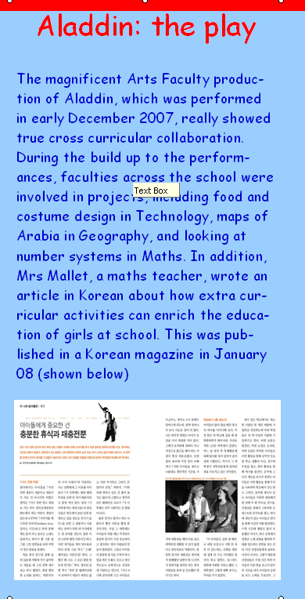
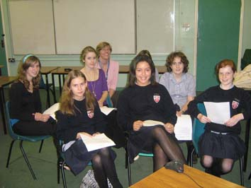
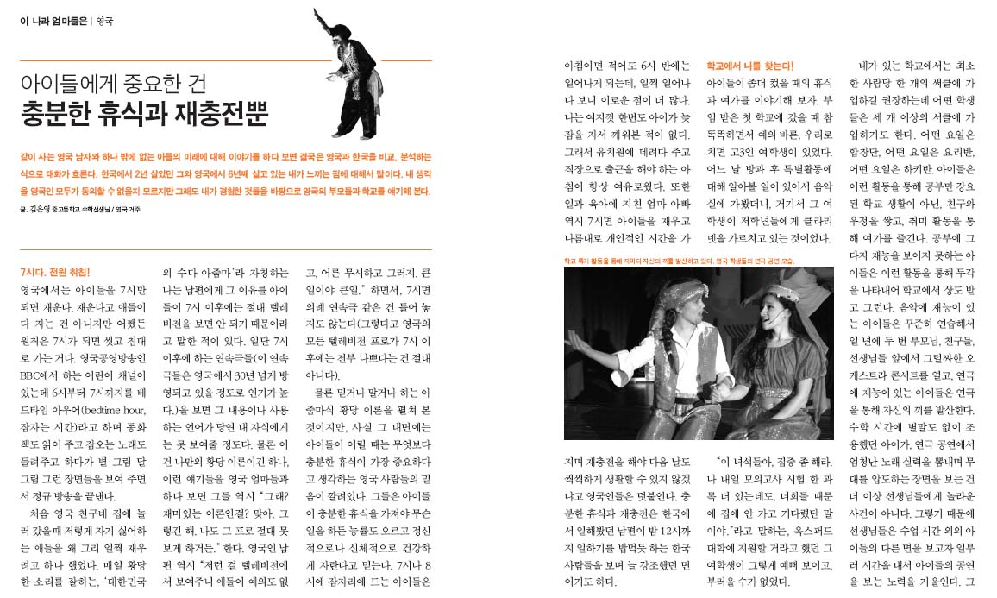
On the 27th November we had a video conference with Sweden and our partner school in Afghanistan. The main purpose of this discussion was to find out what it is like to live and be educated in Afghanistan. Such questions included: What subjects do you learn? Is your school private? How many pupils go to your school? And what are you scared of? The answers were very interesting and sometimes surprising.
We all really enjoyed ourselves and we look forward to future communications with our partner school. The Geography Club
Video Conference with Afghanistan
The magnificent Arts Faculty production of Aladdin, which was performed in early December 2007, really showed true cross curricular collaboration. During the build up to the performances, faculties across the school were involved in projects, including food and costume design in Technology, maps of Arabia in Geography, and looking at number systems in Maths. In addition, Mrs Mallet, a maths teacher, wrote an article in Korean about how extra curricular activities can enrich the education of girls at school. This was published in a Korean magazine in January 08 (shown below)
Aladdin: the play
On the 27th November we had a video conference with Sweden and our partner school in Afghanistan. The main purpose of this discussion was to find out what it is like to live and be educated in Afghanistan. Such questions included: What subjects do you learn? Is your school private? How many pupils go to your school? And what are you scared of? The answers were very interesting and sometimes surprising.
We all really enjoyed ourselves and we look forward to future communications with our partner school. The Geography Club
The magnificent Arts Faculty production of Aladdin, which was performed in early December 2007, really showed true cross curricular collaboration. During the build up to the performances, faculties across the school were involved in projects, including food and costume design in Technology, maps of Arabia in Geography, and looking at number systems in Maths. In addition, Mrs Mallet, a maths teacher, wrote an article in Korean about how extra curricular activities can enrich the education of girls at school. This was published in a Korean magazine in January 08 (shown below)
Aladdin: the play

