Flood Shocks Boscastle

By ace reporter Abbie

On the 16th August 2004 a tragedy occurred in Boscastle. The river Jordan flooded by 2 million tons of rain water. The towns damage was worth £50 million. There was only one injury but over 1000 people were affected.

Yesterday, a shock hits Boscastle badly. The river Jordan flooded by the water rising because of 2 million tons of rain. A local said “I’d seen the water rising, and didn’t think it was right, so I called 999!”

People were evacuated when the helicopters came but some had to wait on their roofs for over 2 hours waiting for the helicopters to come to them.

Cause
There was a tremendous rain which pushed against the wind, which when the wind calmed down it caused a down pour on the river
Valley. The water level rised which caused the river to flood.
Damage
Houses and hotels were destroyed, while cars, buses and vans were washed down through the roads and into the sea.
Missing
During this flood 116 cars washed down the street from the car park. 84 of these cars were discovered in the sea but 32 cars have not yet been found.

Hopefully Boscastle will be built as good as new. Thankfully the only injury was in fact a broken thumb and no pets or animals got washed away, killed or injured.
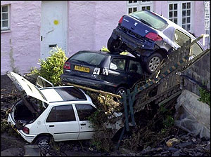
Cars piled up while being swept down the road.

