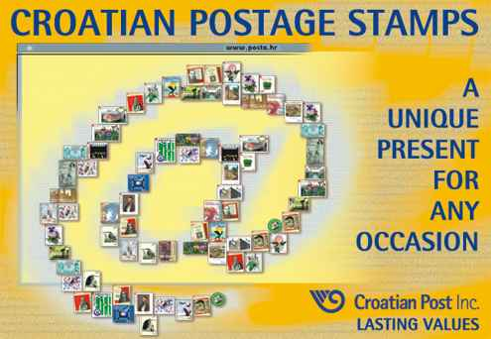 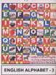  ...
A chain stamp game
CHOOSE ONE STAMP AND START CREATING AN NCREADIBLE STORY!
1. 2.  3.  4.

5.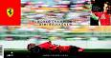 6.7. 8. 

9.  10. 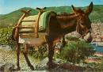 11. 12. 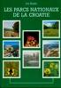
KEEP ON CHOOSING
……..

13. 14. 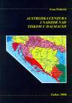 15.  16. 

17.  18. 19.  20.

