HOW ARE YOU? (¿CÓMO ESTÁIS?)

This is our English teacher from Lope de Vega Primary School in Casariche.

Her name is Maite.

Teacher

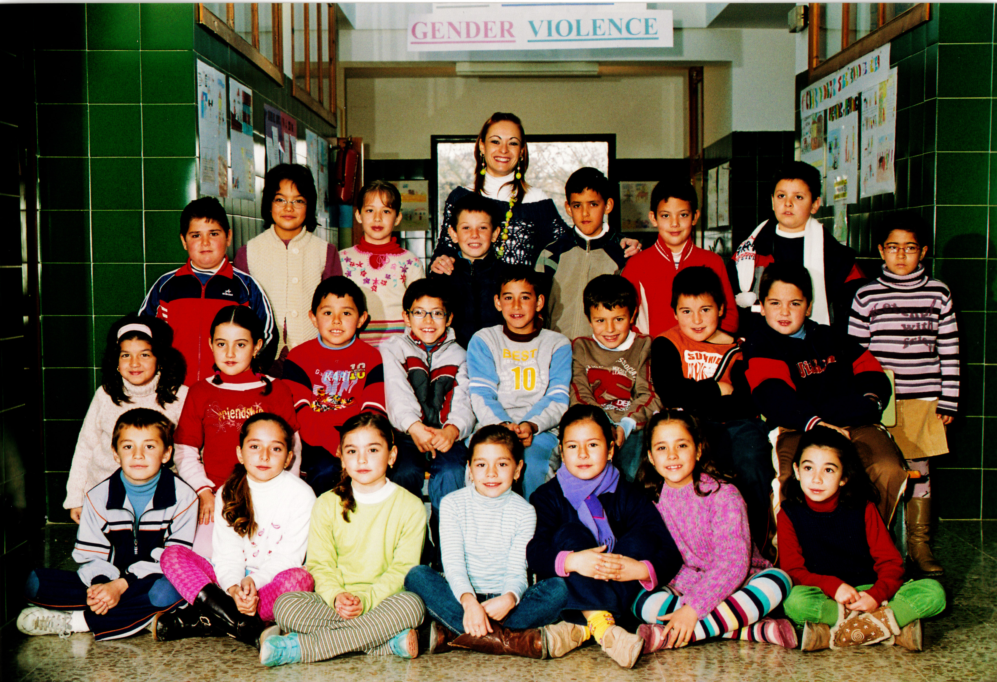

Os presentamos las tres clases que tenemos de 5º curso de Primaria.

In Year 5 we have 3 classes.

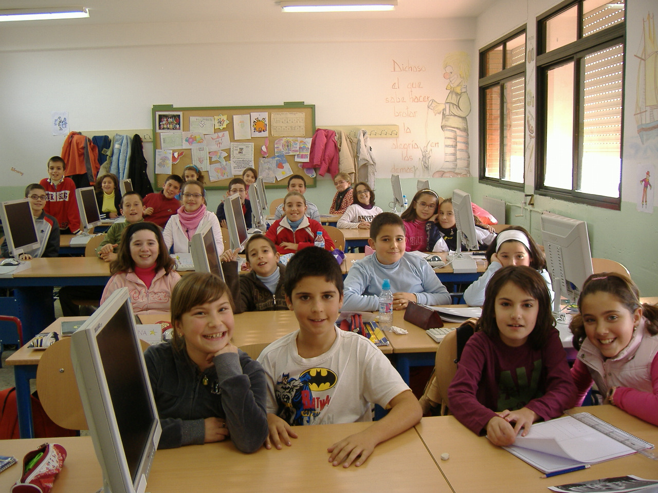

This is 5A

This is 5B

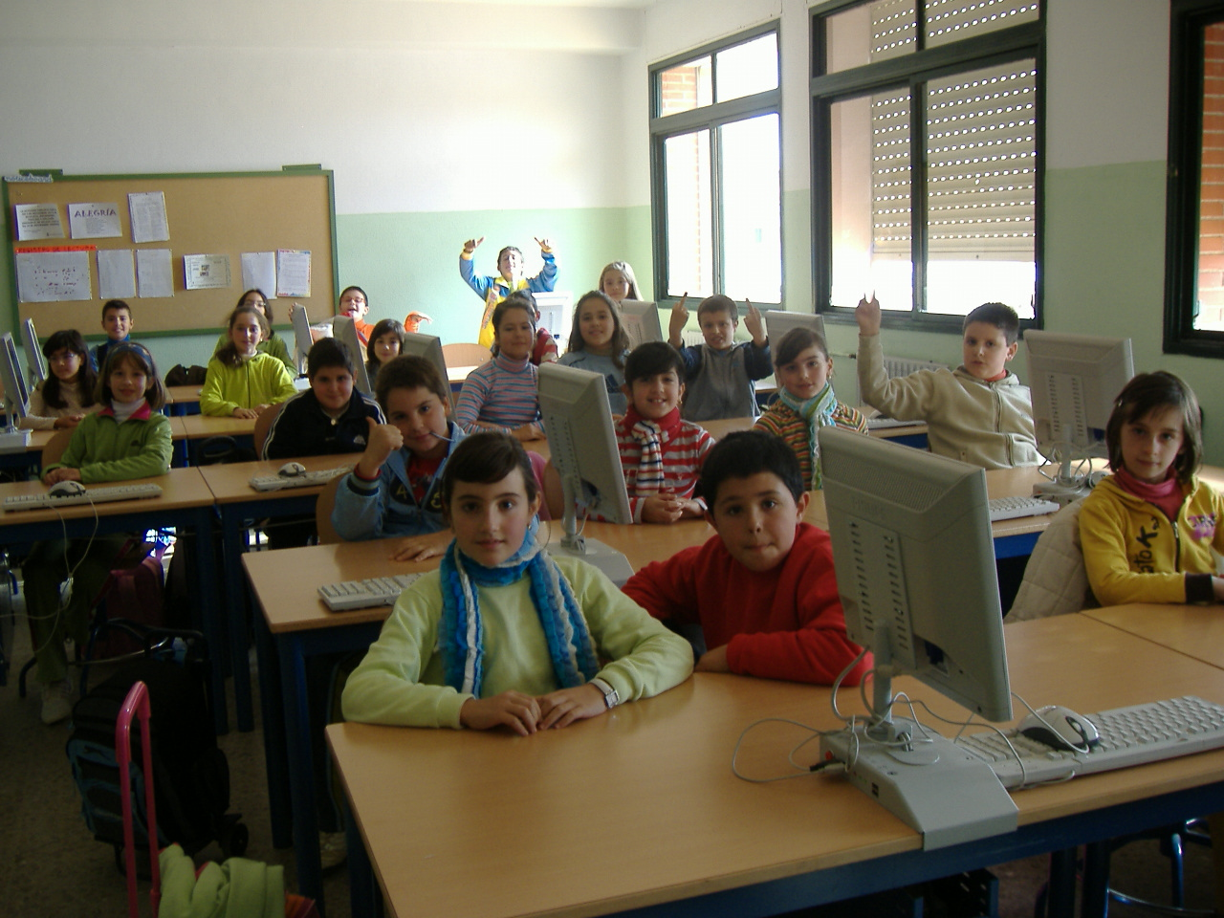

This is 5C

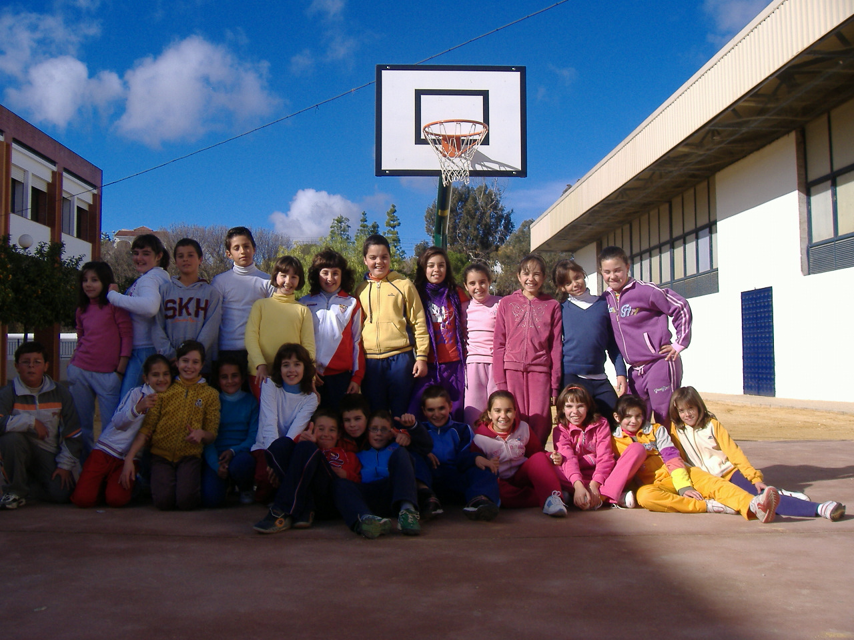

This is our village called Casariche in Seville (Spain)

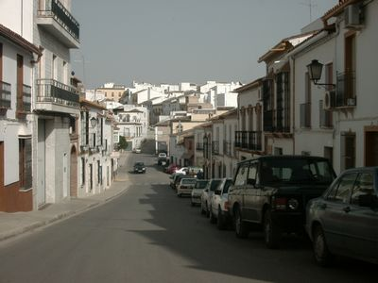

We will be back in touch soon with more information about our school and our village.

Adios! Recuerdos a todos/as

Give my love to the children

La maestra y sus alumnos

