School Emblem
Saraswati
Saraswati-the goddess of learning, knowledge and wisdom-symbolises ideal teacher.
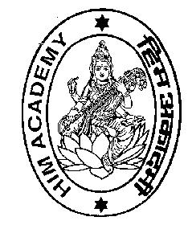
Saraswati literally means the one who gives the essence of one's ownself .
Saraswati has four hands representing
The four aspects of human personality viz. mind, intellect, consciousness, and ego. The hand representing the consciousness holds the book as a symbol of learning and knowledge. The other two hands
representing the mind and intellect, constantly play the lute suggesting that the teacher tunes the mind and intellect of the students, inspiring him / her to be in perfect harmony with the universe within and around him/her.
The fourth hand representing the ego, holds the rosary as a symbol of contemplation and meditation on learning and knowledge so as to sharpen the wisdom.
Saraswati sits on lotus. It symbolises that the teacher is well established in the subjective experience of the truth, which he / she is expected to propagate among the students.
Saraswati has swan as her vehicle, which is the symbol of power of discrimination, to absorb good from bad. Mythologically, this bird is said to possess the ability to drink milk alone out of a mixture of milk and water.
Saraswati is wedded to the creator Brahma, symbolising that learning, knowledge and wisdom are essential for every creation.

