Projet d’anglais : Nourriture

In Christmas, in Switzerland, we eat a special meal in family:

Aperitif: We eat salmon with toast and lemon. We eat too fois gras with toasts. There is caviar for the rich. There are charcuterie and dread meat. We drink Champagne! We the children, we drink orange juice.

Next for main menu we eat turkey with an orange and chestnut sauce and potatoes. We drink red wine.

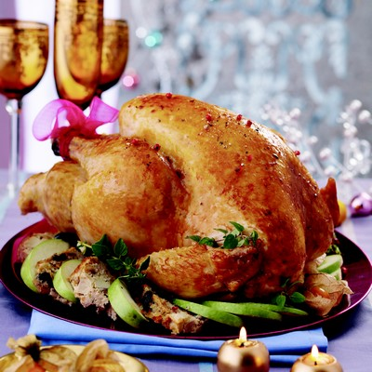

Cheeses: Many people in Christmas eat cheese. Switzerland is a country that produces many cheeses, and is highly regarded. As cheeses is the Gruyère, the Emmental , the cheese raclette . The Swiss typical meal is the fondue. Adults drinks red wine and children drinks the children‘s drink (without alcohol).

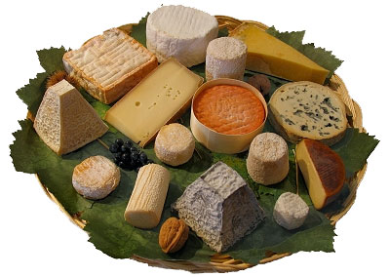
In Christmas, we eat normally “la bûche de noel”.
And this is the recette:
Pour le gâteau roulé :
- 30 g de fécule de pomme de terre
- 30 g de farine
- 90 g de sucre en poudre
- 2 œufs
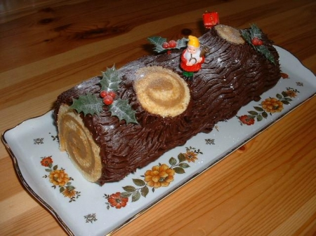

But it’s in Swizerland and I’m Italian. So I eat for the dessert in Christmas”il Panettone”
This is the recette:
-600g de farine
-150g de raisins de Corinthe
-100g de sucre en poudre
-100g de fruits confits ou de fruits secs de votre choix
-200g de beurre fondu
-100g d'amandes effilées
-12cl de lait
-3 oeufs
-une pincée de sel
-1 zeste de citron
-30g de levure de boulanger

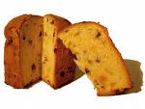

In generally Christmas we eat in family and than we receive the presents.

