The Christmas decoration

In Switzerland, for Christmas, the houses and the streets are decorated. The streets are illuminated with garlands.

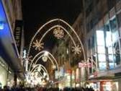

We decorate Christmas trees. They are balls, garland and a beautiful star.

(photo)

Sometimes, we put a Christmas wreath, some mistletoe or holly on the door of entry to the
house. We light candles.

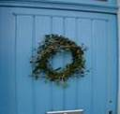
We have calendar to wait Christmas. Every day, we open a window. In the window it was a chocolate or a picture.


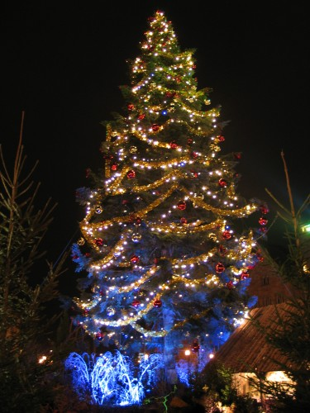

Happy Christmas!!!!

