The Street Market of Christmas

Every winter, in Lausanne, to the 28th of November until the 24th December, there is a Christmas` Market. The place was the market take place is called “The St-François place, au Coeur de la Ville». The Market is not very big but it’s so cute. The people are good.
There are fifty little chalets, where they sell some mulled wine, some brimless, some caramels, some candlestick, some delicacy and a lot of decorations. In Lausanne, normally the shops closed at 6 o’clock but during the feast’s periods, they organize the nocturnal shopping and the shops open until 10 o’clock.
In the town, the most important buildings are illuminated and decorated. There is very beautiful because there were olds buildings.
A little history

The story of Street Market is very old. It began in the 14 century in “Alsace”. In Munich the first street Market began in 1642.
We found some gingerbread and some kind’s clothes. In 1806 they changed the name and they called “The Christmas Market”.
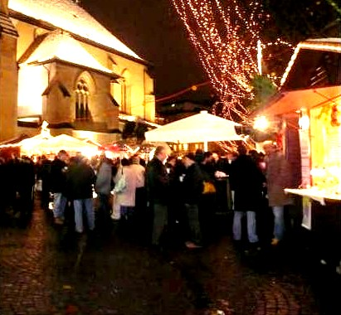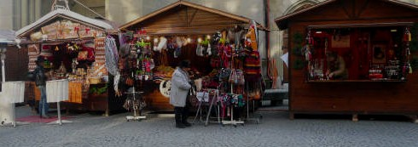
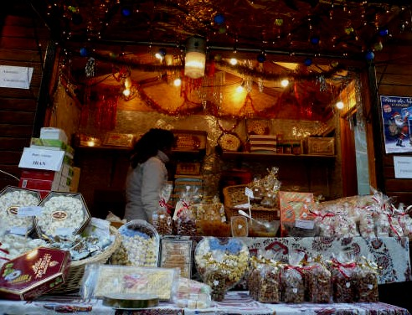

Picture: The market in St François with the chalets and the decorations.

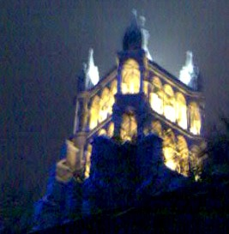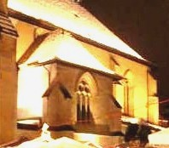

Picture: The important buildings are illuminated
(Left: The Cathedral. Right: The St-François Church)

In summary the Market of Lausanne is attractive und beautiful .The majority of people like to walk in it and look the buildings illuminated. For the kind the father Christmas play music and distribute some present in Market Street .

