Gifts

When it’s Christmas in Lausanne, the people go to special shops and try to find a present for their children, their family, their friends … sometimes, it’s very hard to find what you’re looking for but if you don’t find it, you must think to another present to give to the person that you love. I think it’s also like that in England and in a lot of countries.
The people don’t go anywhere for find the presents that they must give to their children, their family, their friends … They go to special shops like Athleticum, Toys’r us, Payot …
So, when it’s Christmas, the people are very excited and happy.
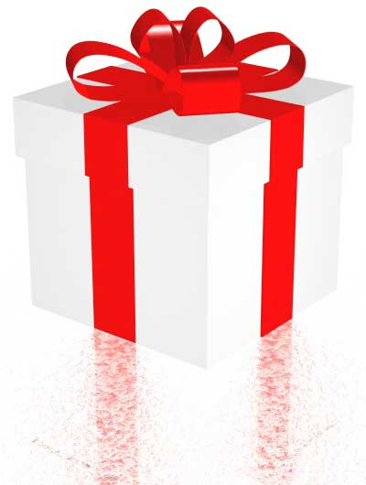

The value of the presents

The value of the presents changes according to several things. More somebody is old, more he get a nice present; a natel, a laptop, voyages... Expensive presents ! And if people are from the same family, they give big presents too. But friends give small presents (earrings, books...). Some years ago, people got small presents for Christmas. Now, people get presents more improved !

The presents of Christmas

The presents ot Christmas change according to the age of who we want to give.
We give more easily a game or a fluffy animal for a littel kid. For a kid of 7-10 years old, we give a book-game, a toy.
For a teenager, we can give money because choice is difficult or a little jewel ( for a girl ) or a watch ( for a boy ).
An Adult receive more a book or a voucher for a trip.
The presents more easy to choose are those who are for toddlers. For the teenagers, it is more difficult to know what they want.

