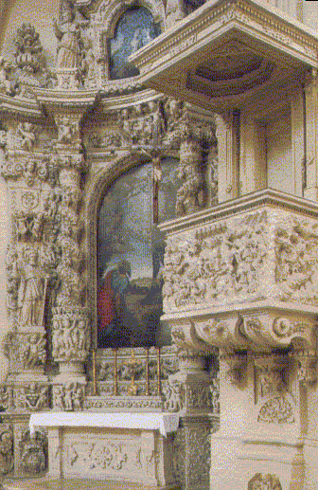
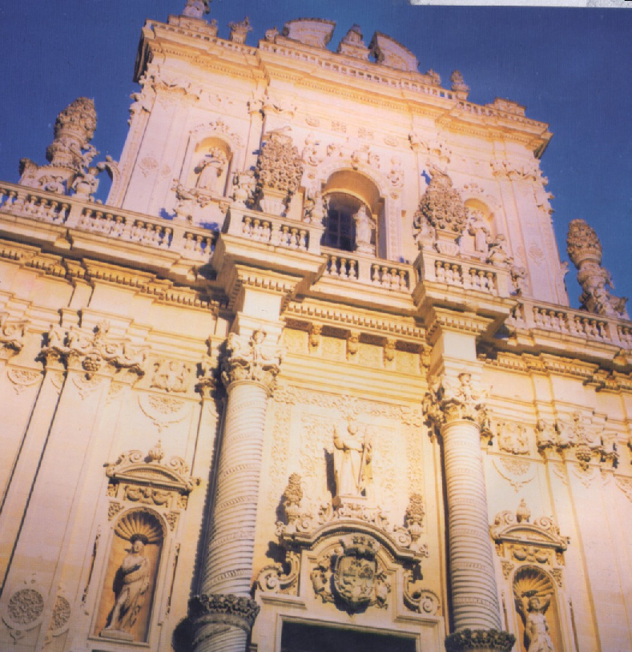

ALTAR OF THE CHURCH OF THE ROSARY OR ST.JOHN THE BAPTIST
the last work of G. Zimbalo (1691-1728), very rich in sculptures and magnificent decorations.
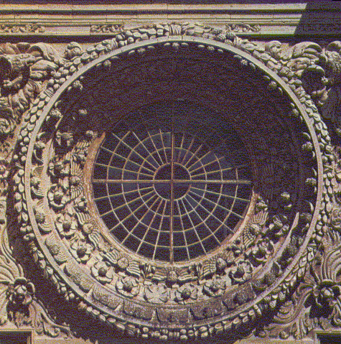
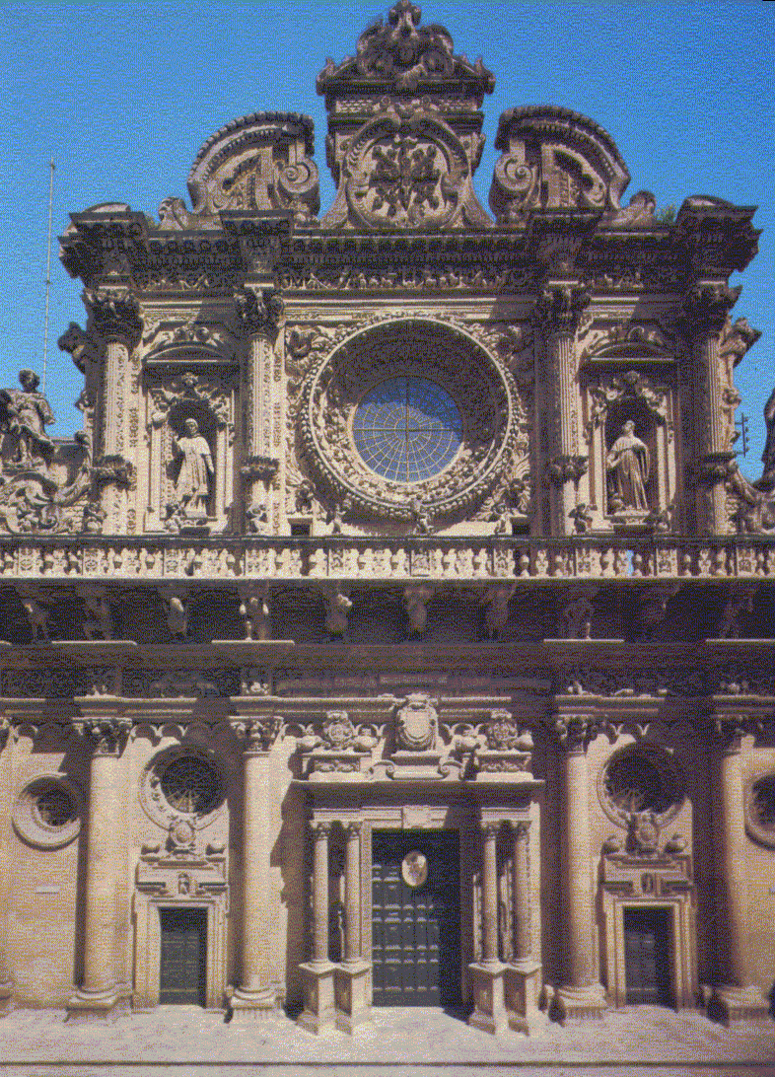

THE CHURCH OF THE HOLY CROSS:
It is the most known example of the “Leccese Baroque”. The facade, quite simple in the lower part, is very rich in decorations in the central and upper parts.

