Kilkenny Bay

I can hear the waves crashing, the trees hustling and the wind blowing.

I can smell the salty seawater.

I see rocks, pebbles, stones, sea woodlice and red spiders.

The rocks all have different colours on them.
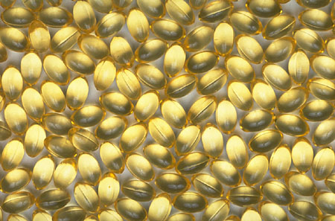
By Ethan Bishop

