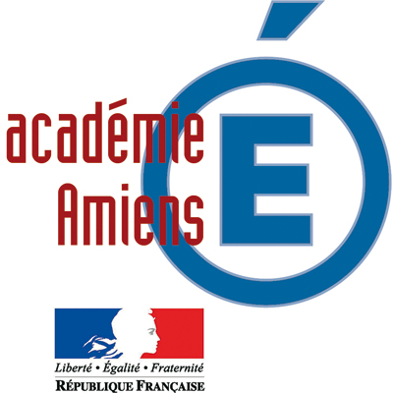

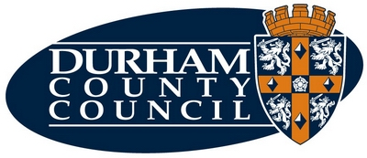
Coopération Agreement
between
L’Académie d’Amiens

and
Durham County Council




Within the framework of the Le Touquet Agreement and the renewal signed in Paris on 9 June 2006, and with the support of the British Council and the French Education Ministry, Durham County Council and the Académie of Amiens have agreed to establish a programme of cooperation between their two regions.

In particular we seek to develop ;

- Pupils of all ages who are confident and competent in their use of the target language,
- Young people who have a developed understanding of their place in an interconnected global community,
- Learners who make purposeful use of new information and communications technologies,
- Teachers who are confident in their use of the taught language
- Schools which are welcoming of new initiatives to transform learning and develop skills of pupils and their learning mentors.

Both partners have agreed :

- To establish sustainable bilateral partnerships between primary, special and secondary schools in both regions
- To initiate collaboration between University departments and higher education institutions
- To offer professional development opportunities for teachers of all subjects
- To arrange bilateral contact seminars
- To exchange information and expertise, in particular on foreign language teaching

- ACTION PLAN

- December 2007 – Durham County Council to host the visit of a delegation from the Académie of Amiens, led by the Recteur in order to sign the agreement. An invitation to make a rerturn visit will be presented at this time.

- To link 50 primary schools from each region by 2009

- To involve 15 secondary schools from each area in a video conferencing project in 2008. The project will be launched during a video conference.

- Organisation of a bilateral contact seminar for 15 secondary schools to work on joint curriculum video conferencing projects – Spring 2008

- To arrange work experience placements as part of the Europass scheme for pupils in vocational education courses.

- To host workshadowing training events in partner schools for teachers from both regions
  - County Durham to host teachers particularly those who teach in the medium of English in European sections
  - Academie d’Amiens to host teachers from both primary and secondary schools

- To encourage co-operation between local authority/Academie staff to support transnational measures.

- To encourage the movement of young people between the two areas.

- To encourage individual immersion homestays.

- FINANCE

Current national and European Union programmes may offer financial support to the initiatives outlined above. Partnered schools will be encouraged and supported in accessing available funds. In particular ;
- Anglo/French pupil and teacher fellowships as agreed in the Paris Accord
- Leonardo programme
- Comenius school partnerships
- Comenius professional development grants
- European Union Youth in Action programmes
- All other programmes of the type described above

- ROLES AND RESPONSIBILITIES

A working group to sustain the partnership will be set up. Brian Stobie, International Officer will represent Durham County Council and Chantal MANES, DARIC and Philip Simmonds, responsible for English speaking countries will represent the Académie of Amiens.

They will be responsible for carrying out the agreed actions and for setting dates for the planned actions.

The proposed initiatives will be monitored and reported each year. Success criteria will include the numbers of linked establishments, the number of pupil and staff mobilities, the value of added external funding as well as report on the qualitative impact of the project on pupils’ skills, knowledge and cultural understanding of the partner region.

- DURATION AND RENEWAL

The agreement is valid for three years including the academic year 2007-2008 and covers the action plan for the first two years.
Further action will be agreed at the end of the second year to cover the third year of the agreement.

The agreement can be renewed at the end of three years if both parties wish to do so.

The agreement is signed in duplicate in both French and English this 7th day of December 2007 in Crook, County Durham by the signatories below who are legal representatives of both organisations.

Tanneguy LARZUL  Recteur d’Académie  Chancelier des Universités  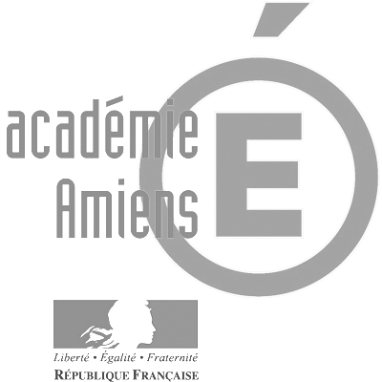  Académie d'Amiens |  | Cllr Edna Hunter  Chairman  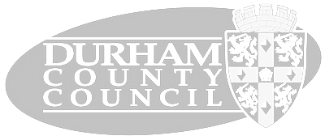  Durham County Council

