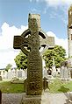
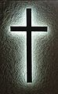
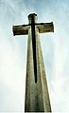


The cross is the best known religious symbol of Christianity. It reminds Christians of God’s act of love when he gave away his son Jesus to save us all. The cross is also a reminder of how Jesus defeated Evil and death when he resurrected.

Hannah

