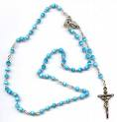

We made rosaries out of clay and dough we had to roll them into balls and poke a hole through the middle. We made rosaries in blue brown, silver and black bead shapes. A rosary is something that Catholics use to pray they keep it round there neck. Each bead represents a prayer and when people pray they hold each beads at a time. A rosary could be made out of glass, crystals, pearls, rose petals and wood. People would get a rosary for their first Communion and keep it for life very preciously. Many Catholics are buried with their rosary in their hands.

Eve Year 4 Sequoia

