Their visit
It was the pleasant month of February when our esteemed guests visited us. We were waiting eagerly for their arrival and every student of our school was imagining about them. During our morning Assembly, they arrived our school. We looked out of windows and saw four pretty women coming out of School’s jeep. Though the eyes of all students were closed, their minds and ears were alert. After a few minutes, they were with us in our M.P. Hall. What a pleasant surprise it was. All eyes set upon them. They were introduced to all. They recorded our assembly activity and were surprised to see that every activity was done by students. Later they visited our classes also. I was teaching in VII class. Among them were Mme. Marian Davis, Zoe Pettit, Farhat Khan and Cameroon. They were from Birmingham. We knew a little about them as our authorities managed everything.
All our activities were watched by them. They were taken to nearby places and shops. One of our staff member’s son’s marriage was about to take place so we thought it a unique chance to acquaint them with our culture and traditions. I had purchased some beautiful sceneries for them and my son presented them those things. They were so pleased and we befriended in no time.
On the day of marriage they expressed their wish to have Indian like look so they dressed up like that. I did their makeup and they were looking so pretty. Davis madam and Zoe had become so familiar to me and as long as they stayed they ever conveyed their feeling to me. It seemed as if we knew each other for a long time. Whenever I visited them, my son also accompanied me as he had never seen so loving people. He showed all his drawings to them and Zoe had developed a special liking for him. Even now whenever
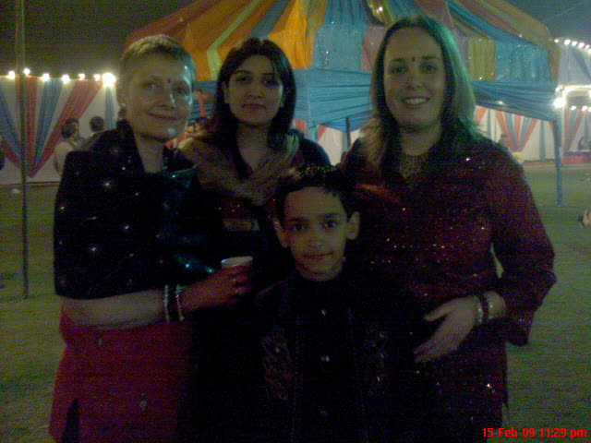She sends me emails she never forgets to mention him. He is too eager to know about her news.
We enjoyed a lot in the marriage party I told them about all our traditions and culture. It was their first visit to India. Zoe thinks it was unique as it gave them a chance to know Indian people better. She promised me to visit again.

