Theodora‘s Book Review
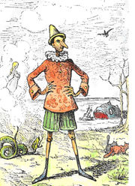
Book Title: The adventures of Pinocchio
Author: Carlo Collodi
Illustrator: Enrico Mazzanti
This book was about
This book was about a wooden boy and his father.

My favorite character in this book was
My favorite character in this book was Pinocchio – I liked Pinocchio because his friend and he are kind-hearted.

I liked this book because
I liked this book because I learned to be friendly and how to help animals.

You should read this book because
You should read this book because it is interesting and you can learn a lot.

