Dr APJ Abdul Kalam

“We have made significant achievements in the last fifty years in food production, health sector, higher education, media and mass communication, industrial infrastructure, information technology, science and technology and defence. Our nation is endowed with natural resources, vibrant people and traditional value system. In spite of these resources, a number of our people are below the poverty line, undernourished and lack primary education…Along with speedy development aimed at elimination of poverty and unemployment, national security has to be recognized by every Indian as a national priority. Indeed, making India strong and self-reliant—economically, socially and militarily—is our foremost duty to our motherland and to us and to our future generations.”

Dr. Kalam in his speech on the occasion of his assumption of office as President of India on July 25, 2002

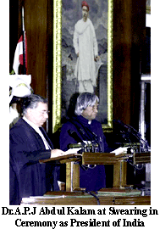

Dr APJ Abdul Kalam, an eminent scientist and engineer has also served as the 11th President of India from the period 2002 to 2007. He is also often also referred to as the Missile Man of India. People loved and respected Dr APJ Abdul Kalam so much during his tenure as President that he was popularly called the People's President. Dr APJ Abdul Kalam is a man of vision, who is always full of ideas aimed at the development of the country. He firmly believes that India needs to play a more assertive role in international relations.

Dr APJ Abdul Kalam was born on 15 October 1931 at the South Indian state of Tamil Nadu and received honorary doctorates from about 30 universities globally. In the year 1981, the Government of India presented him the nation's highest civilian honor, the Padma Bhushan and then again, the Padma Vibhushan in 1990 and the Bharat Ratna in 1997. Before Kalam, there have been only two presidents – Dr. Sarvapalli Radhakrishnan and Dr.Zakir Hussain - to have received the Bharat Ratna before bring appointed to the highest office in India.

Dr APJ Abdul Kalam has a vision to make India a developed country. He has given his plan of action and a road map for realizing his vision. He has articulated his thoughts in his three books: India 2020: A Vision for the New Millennium, Wings of Fire: An Autobiography of A. P. J. Abdul Kalam and Ignited Minds: Unleashing the Power Within India. India has already started looking to Dr. Kalam for inspiration and guidance.

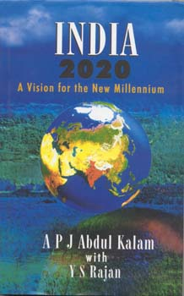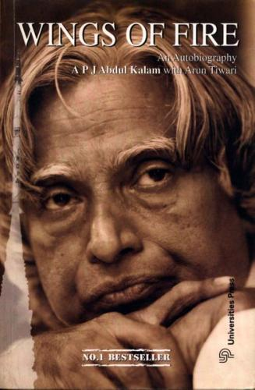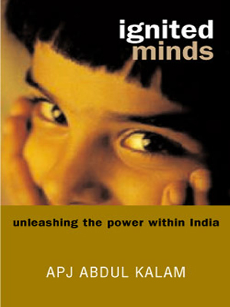

Dr APJ Abdul Kalam regards his work on India's nuclear weapons program as a way to assert India's place as a future superpower. He has even put forward a project plan for establishing bio-implants. He is also an ardent advocate of open source software over proprietary solutions to churn out more profits in the field of information technology in India.

After studying in a primary school in Rameswaram, Dr. Kalam went to Schwartz High School at Ramanathpuram from where he went to Tiruchchirapalli for his higher studies. After completing his BSc from St. Joseph’s college, Tiruchchirapalli, he joined the Madras Institute of Technology (MIT), for studying aeronautical engineering. From MIT, he went to Hindustan Aeronautics Limited (HAL) at Bangalore as a trainee. After completing his training Dr. Kalam joined the Technical Centre (Civil Aviation) of the DTD&P (Air) as Senior Scientific Assistant on a basic salary of Rs. 250/-. While working at the Air force Directorate he got a chance to realise his dream. He joined the Indian Committee for Space Research (INCOSPAR), the predecessor of the Indian Space Research Organisation (ISRO). And thus Kalam started his much talked about career in rocket and missile technology.

Dr. Kalam’s career can be divided into four phases. In the first phase (1963-82) he worked with the Indian Space Research Organisation (ISRO). At ISRO he was made the Project Director of the Mission for SLV-3. He played a crucial role in developing satellite launch vehicle technology and expertise in control, propulsion and aerodynamics. The SLV-3 project managed to put Rohini, a scientific satellite, into orbit in July 1980. India also acquired the ability to design various kinds of rocket systems.
The second phase of his career started when he joined the Defence Research and Development Organisation (DRDO) in 1982 as Director. Here he was entrusted with the Integrated Guided Missile Development Programme (IGMDP). Dr. Kalam’s contribution to India’s defence capabilities is very significant.
Dr. Kalam identifies his third phase with his participation with India’s mission to become a nuclear weapon state, jointly undertaken by DRDO and Department of Atomic Energy (DAE) with the active support of the armed forces. During this phase he, as Chairman of the Technology Information, Forecasting and Assessment Council (TIFAC), also got involved with the creation of Technology Vision 2020 and the India Millennium Missions (IMM 2020), which is an integrated version of technology vision and India’s security concerns. In November 1999 Dr. Kalam was appointed as Principal Scientific Adviser to the Government of India.
His fourth phase started when he joined the Anna University at Chennai as Professor of Technology and Societal Transformation. As part of realizing his mission he decided to ignite the minds of the young. For this purpose he wanted to reach at least 100,000 students in different parts of the country before August 2003. He has already met about 40,000 students. His fourth phase took a sudden turn, which he himself perhaps did not visualize. He became the President of India.

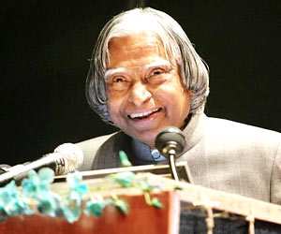
Like Gandhiji, Dr. Kalam believes in simple living and high thinking. He is a very liberal and broad-minded person who has complete trust and faith in secularism. He cites from the Bhagvad Gita as often he does from the Holy Koran. For great men, religion is a way of making friends, small people make religion a fighting tool, he remarks.

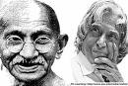

His hobbies include playing the Rudra Veena and writing poetry in Tamil which is his first language.

