OUR SCHOOL

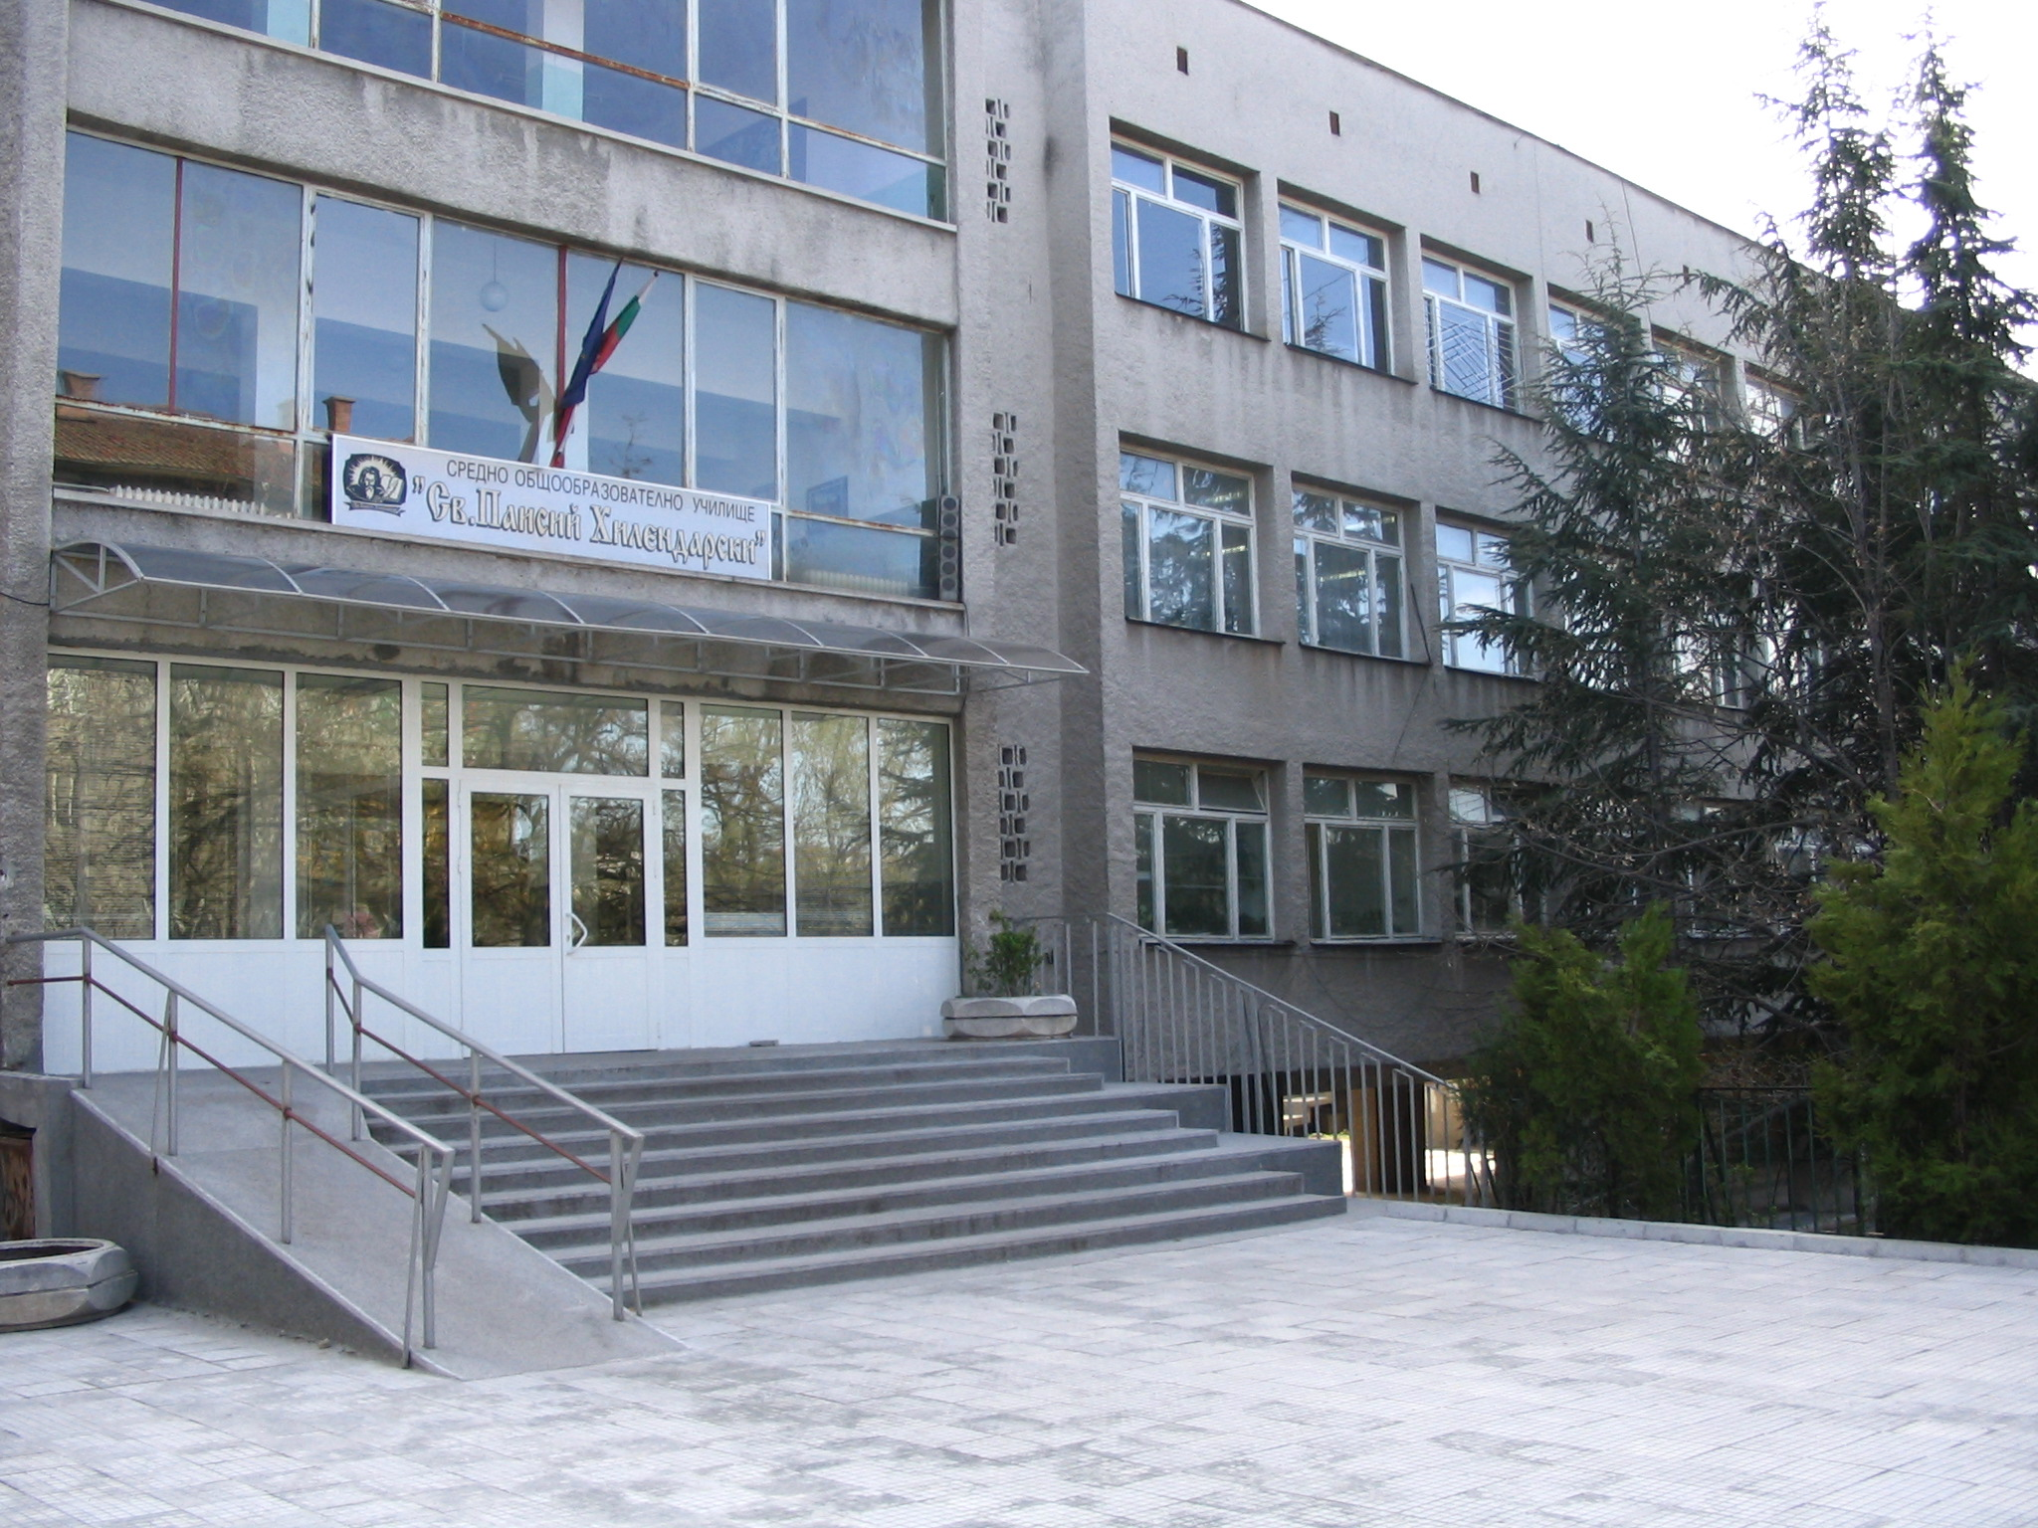

Our school name is “St. Paissiy Hilendarski” high school and it is in Haskovo, in the south-east part of the city. It has 31 classrooms. In the school we have a gym, an assembly hall, a conference hall. We have a school newspaper where students and teachers write articles and stories. The school has an anthem. Our principal is Mrs Nina Staykova. The school patron’s day is on November 1st.

Marina and Tanya from 6b class

