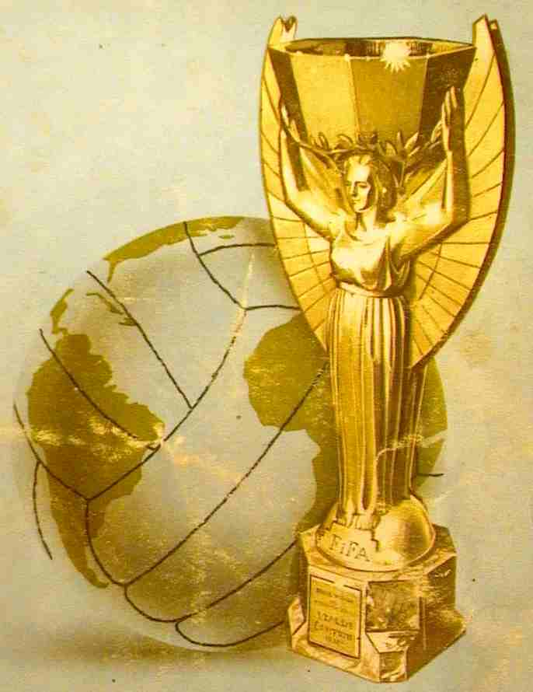
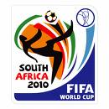
WORLD CUP 2010

TASK 2

Each class must now find out more about the history of their country.

HISTORY TIMELINE

Produce a timeline for your country detailing the famous historical events.
You may wish to include some of the following ideas:
Who are the famous people from your country’s history? What can you find out about them?
What are the most important events in your country’s history?
Can you produce a timeline for the last 50 / 100 / 200 years for your country?

